**Technical Documentation of**

**RILey Robot V1**

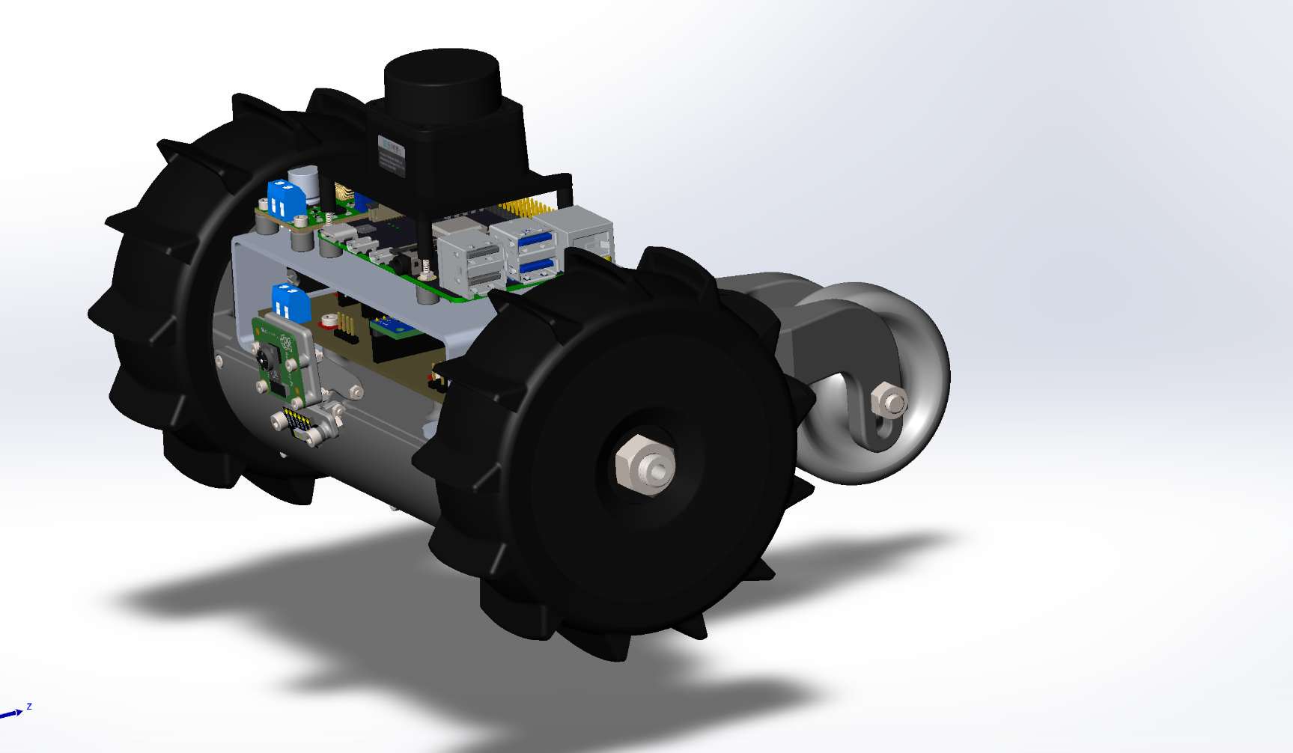

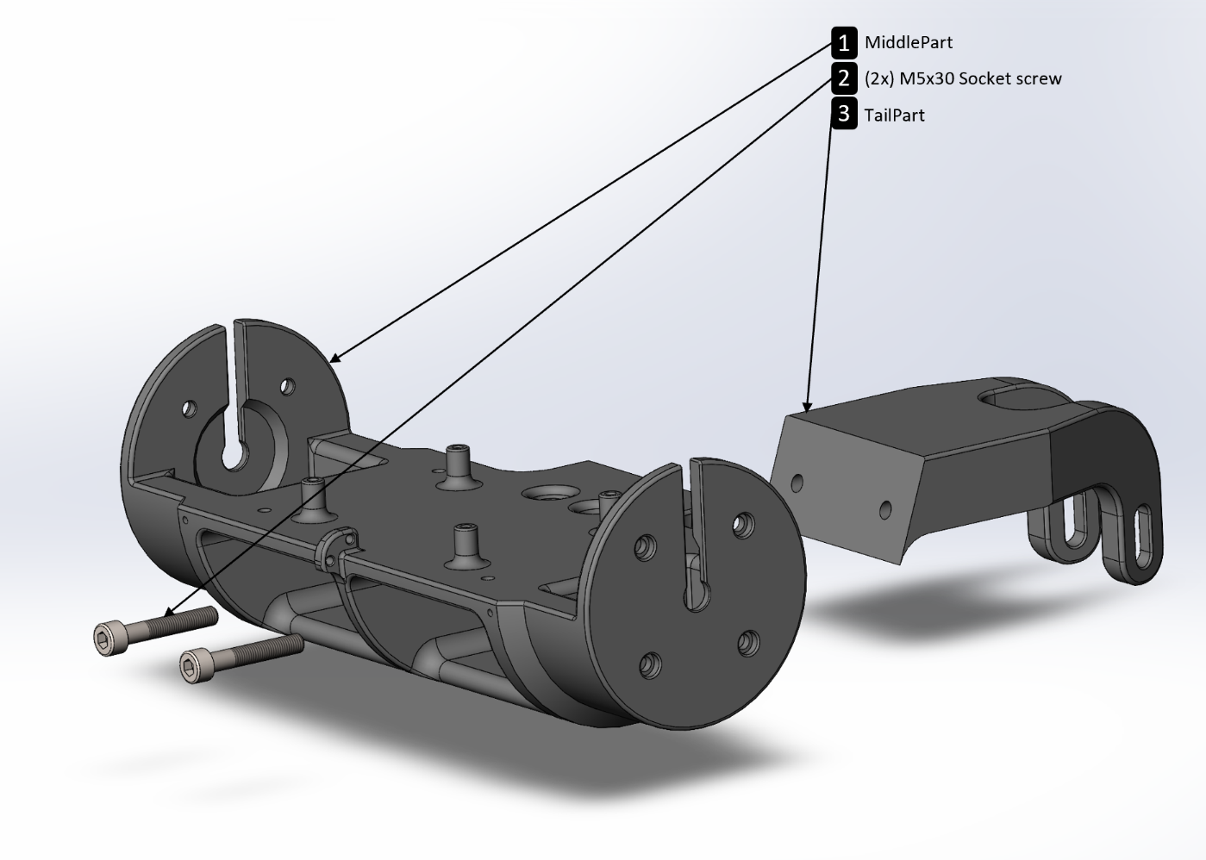**RILey Robot Mechanical design**

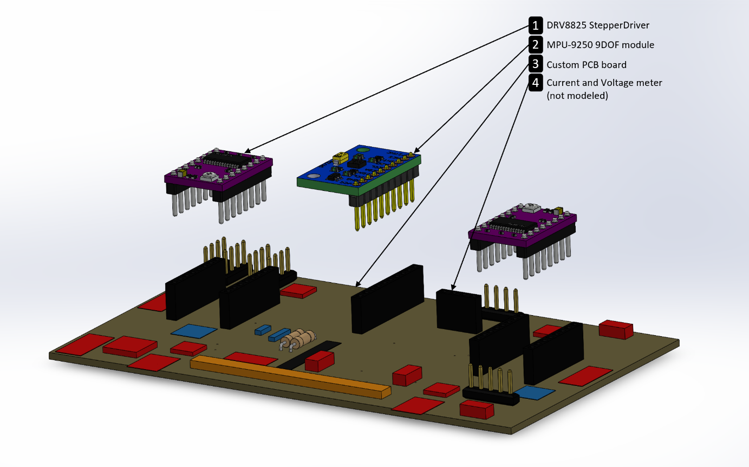Here we have the basis of the RILey robot. It exist out of 2 PLA 3d-printed parts attached to each other with 2 M5x30 socket head screws. Everything eventually will mount onto the ‘MiddelPart’ the reason we separated the ‘TailPart’ form the ‘MiddlePart’ is because it is easier to print it this way and also we were not quite sure how the ‘TailPart’ should look like. The tail is primarily used as a counter weight so if the robot accelerates the whole robot doesn’t spin on it’s back. The design flaw it still has is that it does not have an omni-direction wheel on it. So if the floor is very sticky the robot will not turn very easy. Luckily this design will let you replace the tail in the future.

This is the first version of the PCB. When the PCB is soldered there will mount 4 modules on there. 2 stepper drivers, 1 accelerometer/gyroscope/magnetometer and 1 current/voltage meter.

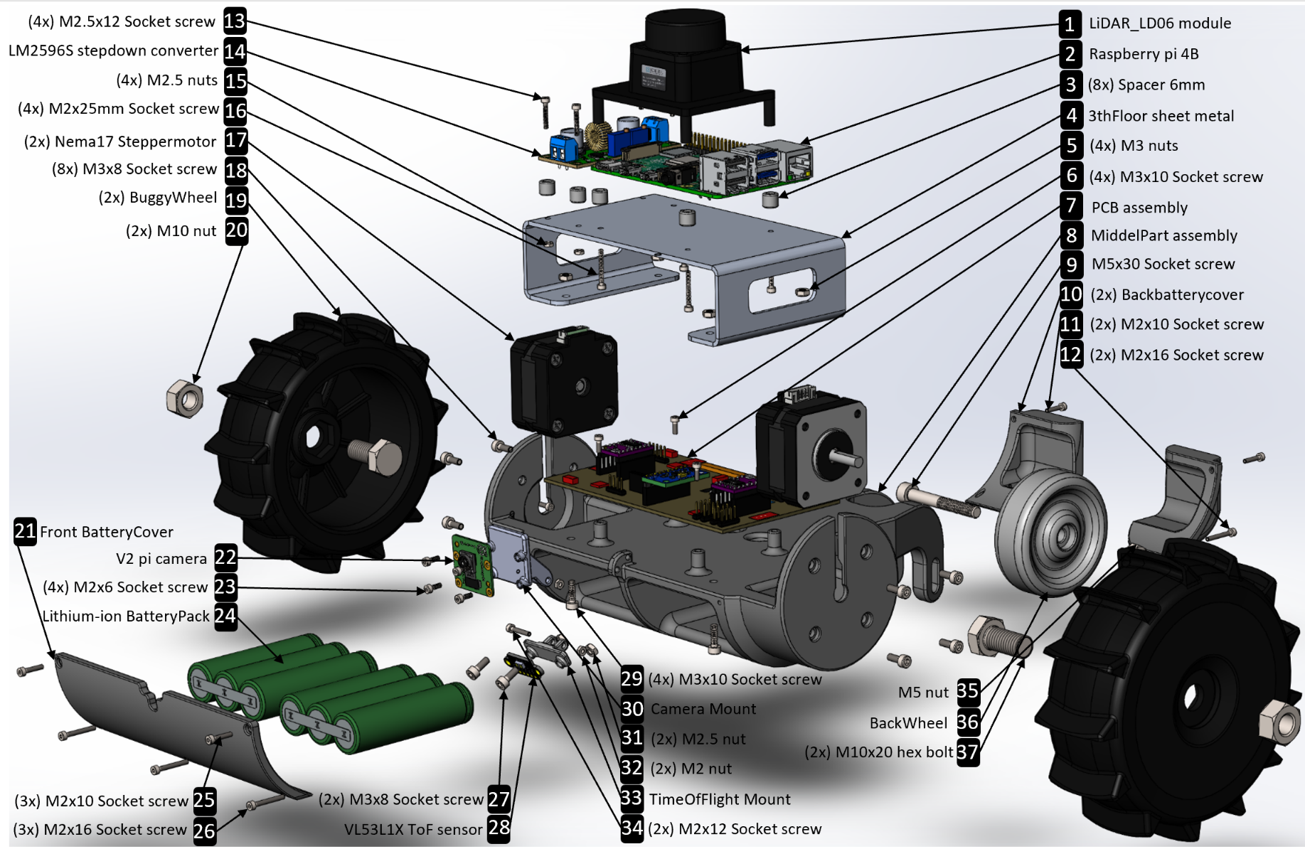This first version PCB still has some flaws which need to be addressed before the final product will be delivered. For example the battery charge and discharge system is currently on a separate protoboard and this needs to be integrated. Furthermore the stepper motors are always enabled if the robot is on. This leads to unwanted power consume if the robot is standing still. The motors could also overheat this way and melt the plastic housing they are in. The main reason the robot has stepper motors is because they don’t make that much noise. But because we are using cheap stepper drivers the motors make some unwanted noise. There is a simple solution to use different stepper drivers the get rid of the noise.

**RILey V1 Robot Order List**

|  |  |  |  |
| --- | --- | --- | --- |
| Items quantity | Part | Supplier | Cost |
| 1 | Raspberry Pi 4B (rev 1.4 RAM 8GB) | www.tinytronics.nl | €85.00 |
| 1 | Raspberry Pi Camera V2 (8MP) | www.tinytronics.nl | €26.00 |
| 2 | DRV8825 Motor Drive Module | www.tinytronics.nl | €11.00 |
| 1 | MPU-9250 Accelerometer | www.tinytronics.nl | €9.75 |
| 1 | VL53L1X ToF distance sensor | www.tinytronics.nl | €11.50 |
| 1 | LM2596 DC-DC step-down converter | www.tinytronics.nl | €3.00 |
| 2 | Nema17 Stepper Motor (26mm thick) | www.tinytronics.nl | €23.00 |
| 1 | INA226 Current and Voltage meter | www.tinytronics.nl | €6.00 |
| 2 | 10cm cable for stepper motor | www.tinytronics.nl | €4.00 |
| 1 | 2x Reely Buggy wheels | www.conrad.nl | €24.99 |
| 1 | LiDAR_LD06 Okdo Module | nl.rs-online.com | €87.64 |
| 2 | 11.1V Lithium-ion battery pack | nl.rs-online.com | €66.10 |
| 1 | MiddlePart | 3D-printed (objex-lab) | €? |
| 1 | TailPart | 3D-printed (objex-lab) | €? |
| 1 | CameraMount | 3D-printed (objex-lab) | €? |
| 1 | TimeOfFlightMount | 3D-printed (objex-lab) | €? |
| 1 | BackWheel | 3D-printed (objex-lab) | €? |
| 8 | Spacer | 3D-printed (objex-lab) | €? |
| 1 | BatteryFrontCover | 3D-printed (objex-lab) | €? |
| 2 | BatteryBackCover | 3D-printed (objex-lab) | €? |
| 1 | 3rdFLoor | Sheet metal (laser cut) | €? |
| 4 | M2x20mm socket head screw | ? | €? |
| 5 | M2x16mm socket head screw | ? | €? |
| 2 | M2x12mm socket head screw | ? | €? |
| 5 | M2x10mm socket head screw | ? | €? |
| 4 | M2x6mm socket head screw | ? | €? |
| 2 | M2 nut | ? | €? |
| 4 | M2.5x12mm socket head screw | ? | €? |
| 4 | M2.5 nuts | ? | €? |
| 4 | M3x10mm socket head screw | ? | €? |
| 10 | M3x8mm socket head screw | ? | €? |
| 6 | M3 nuts | ? | €? |
| 2 | M5x30mm socket head screw | ? | €? |
| 1 | M6x45mm socket head screw | ? | €? |
| 1 | M6 nut | ? | €? |
| 2 | M10x20mm hex bolt | ? | €? |
| 2 | M10 nut | ? | €? |
| 5 | PCB | jlcpcb.com | €28.88 |
| 4 | Female header 8 pin | www.tinytronics.nl | €1.00 |
| 1 | Female header 10 pin | www.tinytronics.nl | €0.30 |
| 1 | Male header 40 pin | www.tinytronics.nl | €0.40 |
| 1 | Female header 4 pin | www.tinytronics.nl | €0.15 |
| 1 | DC Power Connector Jack 2A | www.conrad.nl | €0.68 |
| 4 | WAGO screw clamp | www.conrad.nl | €0.84 |
| 2 | Kogellager binnen diameter 6mm | www.conrad.nl | €2.90 |
| 1 | Molex KK 3.96 female crimp connector | nl.rs-online.com | €0.11 |
| 2 | Molex KK 3.96 female crimp Terminal | nl.rs-online.com | €0.14 |
| 1 | Molex KK 3.96 straight pin header | nl.rs-online.com | €0.25 |
| 2 | 100μF Electrolytic Capacitor | nl.rs-online.com | €0.77 |
| 1 | Slide Switch | nl.rs-online.com | €3.14 |
| 2 | 3M 40-Way IDC Connector 2 row | nl.rs-online.com | €3.44 |
| 1 | Murata 47nF multilayer ceramic | nl.rs-online.com | €0.18 |
| 2 | JST, XH B4B 4way 1 Row Straight | nl.rs-online.com | €0.88 |
| 1 | Nexperia BCM857BS,115 Dual PN | nl.rs-online.com | €0.34 |
| 1 | Vishay SA5.0A-E3/54, uni-Direction | nl.rs-online.com | €0.59 |
| 1 | Through hole resistor 10kOhm | nl.farnell.com | €0.09 |
| 1 | Multilayer Ceramic Capacitor 1μF | nl.farnell.com | €0.32 |
| 1 | Pin Header, Wire-to-Board 2,54mm | nl.farnell.com | €0.56 |
| 1 | Through hole resistor 47kOhm | nl.farnell.com | €0.05 |
| 1 | Power MOSFET, P Channel 100 | nl.farnell.com | €1.08 |
| 1 | Resettable Fuse PPTC 1812 | nl.farnell.com | €0.22 |

Total: 405,29

For more detail where to buy the exact components look at the order lists in excel.

**RILey V2 Robot Order List**

|  |  |  |  |
| --- | --- | --- | --- |
| Items quantity | Part | Supplier | Cost |
| 1 | Raspberry Pi 4B (rev 1.4 RAM 8GB) | www.tinytronics.nl | €85.00 |
| 1 | Raspberry Pi Camera V2 (8MP) | www.tinytronics.nl | €26.00 |
| 2 | DRV8825 Motor Drive Module | www.tinytronics.nl | €11.00 |
| 1 | MPU-9250 Accelerometer | www.tinytronics.nl | €9.75 |
| 1 | VL53L1X ToF distance sensor | www.tinytronics.nl | €11.50 |
| 1 | LM2596 DC-DC step-down converter | www.tinytronics.nl | €3.00 |
| 2 | Nema17 Stepper Motor (41mm thick) | www.tinytronics.nl | €22.00 |
| 1 | INA226 Current and Voltage meter | www.tinytronics.nl | €6.00 |
| 2 | 10cm cable for stepper motor | www.tinytronics.nl | €4.00 |
| 1 | 2x Reely Buggy wheels | www.conrad.nl | €24.99 |
| 1 | LiDAR_LD06 Okdo Module | nl.rs-online.com | €87.64 |
| 2 | 11.1V Lithium-ion battery pack | nl.rs-online.com | €66.10 |
| 1 | MiddlePartV2 (PETG) | 3D-printed (objex-lab) | €? |
| 1 | TailPartV2 (PETG) | 3D-printed (objex-lab) | €? |
| 1 | CameraMount | 3D-printed (objex-lab) | €? |
| 1 | TimeOfFlightMount | 3D-printed (objex-lab) | €? |
| 8 | Spacer | 3D-printed (objex-lab) | €? |
| 1 | BatteryFrontCover | 3D-printed (objex-lab) | €? |
| 2 | BatteryBackCover | 3D-printed (objex-lab) | €? |
| 1 | 3rdFLoor | Sheet metal (laser cut) | €? |
| 4 | M2x20mm socket head screw | ? | €? |
| 5 | M2x16mm socket head screw | ? | €? |
| 2 | M2x12mm socket head screw | ? | €? |
| 5 | M2x10mm socket head screw | ? | €? |
| 4 | M2x6mm socket head screw | ? | €? |
| 2 | M2 nut | ? | €? |
| 4 | M2.5x12mm socket head screw | ? | €? |
| 4 | M2.5 nuts | ? | €? |
| 4 | M3x10mm socket head screw | ? | €? |
| 10 | M3x8mm socket head screw | ? | €? |
| 6 | M3 nuts | ? | €? |
| 2 | M5x30mm socket head screw | ? | €? |
| 1 | M6x45mm socket head screw | ? | €? |
| 1 | M6 nut | ? | €? |
| 2 | M10x20mm hex bolt | ? | €? |
| 2 | M10 nut | ? | €? |
| 5 | PCB | jlcpcb.com | €35 |
| 4 | Female header 8 pin | www.tinytronics.nl | €1.00 |
| 1 | Female header 10 pin | www.tinytronics.nl | €0.30 |
| 1 | Male header 40 pin | www.tinytronics.nl | €0.40 |
| 1 | Female header 4 pin | www.tinytronics.nl | €0.15 |
| 1 | 40 Pins header Male - 90 graden | www.tinytronics.nl | €0.50 |
| 1 | DC Power Connector Jack 2A | www.conrad.nl | €0.68 |
| 4 | WAGO screw clamp | www.conrad.nl | €0.84 |
| 1 | Castor wheel | www.conrad.nl | €2.21 |
| 1 | Molex KK 3.96 female crimp connector | nl.rs-online.com | €0.11 |
| 2 | Molex KK 3.96 female crimp Terminal | nl.rs-online.com | €0.14 |
| 1 | Molex KK 3.96 straight pin header | nl.rs-online.com | €0.25 |
| 2 | 100μF Capacitor 25V | nl.rs-online.com | €0.77 |
| 1 | Slide Switch | nl.rs-online.com | €4.13 |
| 2 | 3M 40-Way IDC Connector 2 row | nl.rs-online.com | €3.44 |
| 2 | JST, XH B4B 4way 1 Row Straight | nl.rs-online.com | €0.88 |
| 1 | Pin Header, Wire-to-Board 2,54mm | nl.farnell.com | €0.56 |
| 1 | MOSFET | nl.farnell.com | €0.23 |
| 1 | Polyfuse 5A | nl.farnell.com | €1.50 |
| 1 | Polyfuse 8A | nl.farnell.com | €1.44 |
| 1 | Zener Diode | nl.farnell.com | €0.21 |
| 1 | Capacitor 1500uF 6,3V | nl.farnell.com | €0.73 |
| 1 | Diode Rectifier | nl.farnell.com | €0.57 |

Total: 413,02

For more detail where to buy the exact components look at the order lists in excel.

**RILey Robot Mechanical assembly**

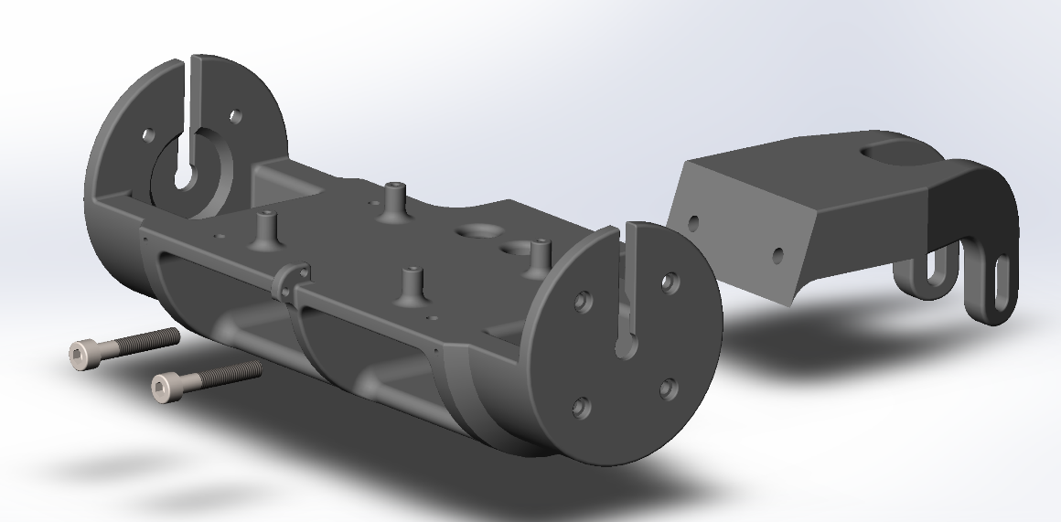Here we are going to assemble the RILey robot in a particular order. It is recommended to follow this order to avoid issues with assembling the robot.

First we use 2x M5x30mm screws to screw the middlepart to the tailpart.

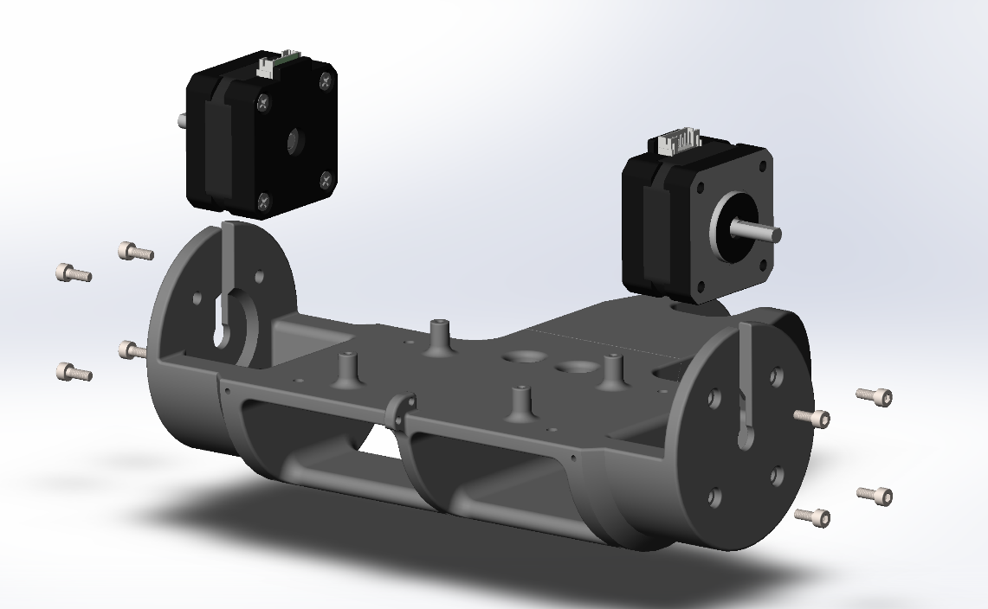

Put the stepper motors in the middlepart and use M3x8mm screws to secure them in place.

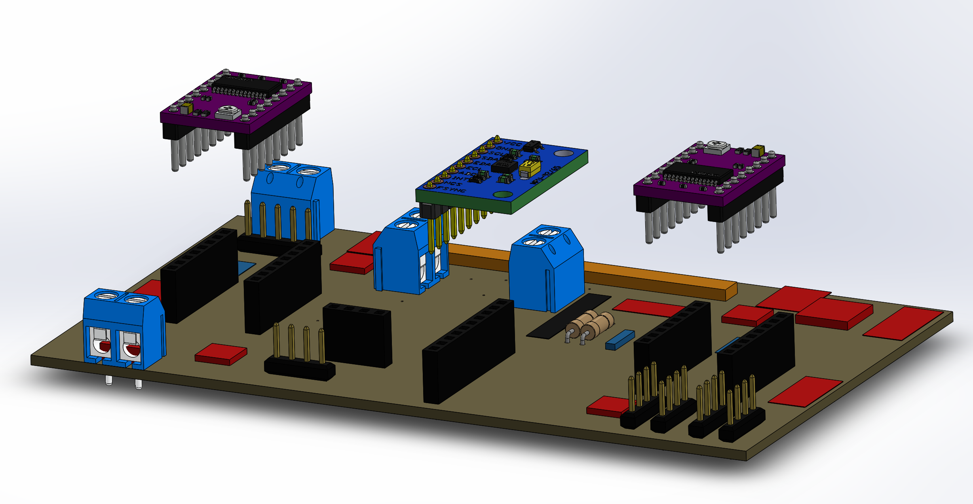

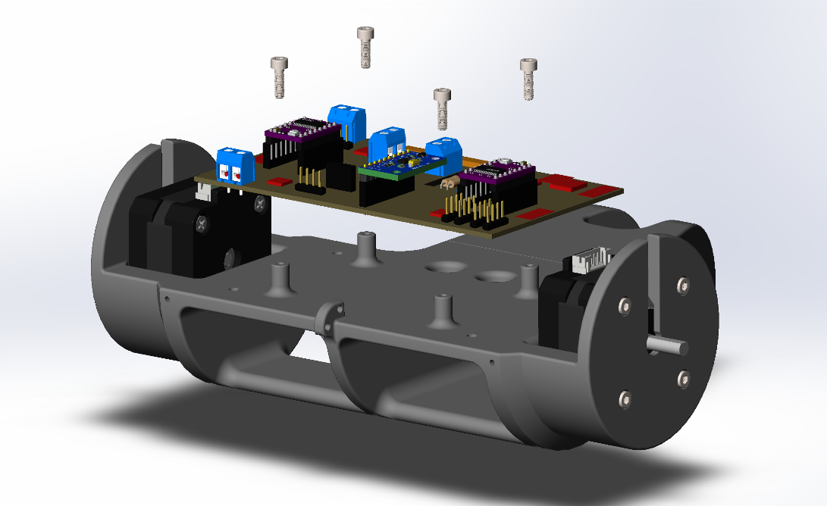Make sure the Stepper Drivers and IMU are facing the correct orientation in order to make the electrical connections right.

Place the PCB on top of the middlepart(pillars) and secure it with 4x M3x10mm screws.

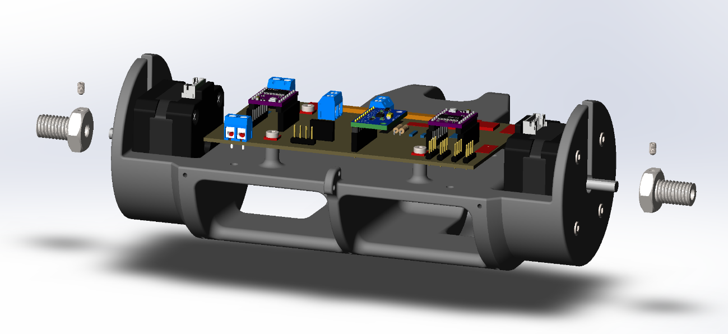Slide the axel hubs onto the stepper motors shaft and secure it with using an M3 set screw. Make sure the set screw bottoms out on the flat surface of the stepper motor shaft.

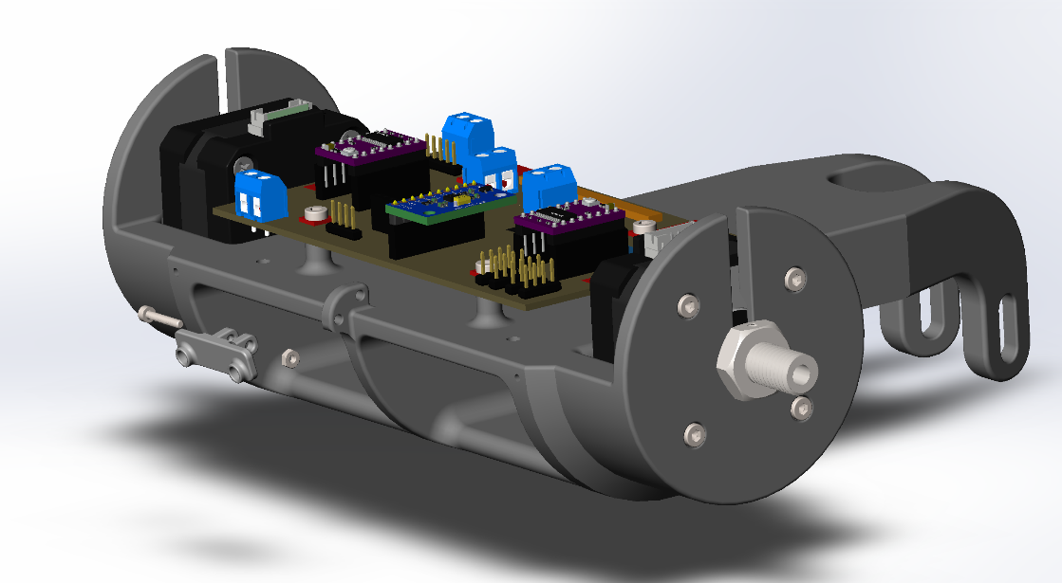Mount the TimeOfFlightMount with an M3x12mm screw and nut on the bottom hole on the front of the middlepart

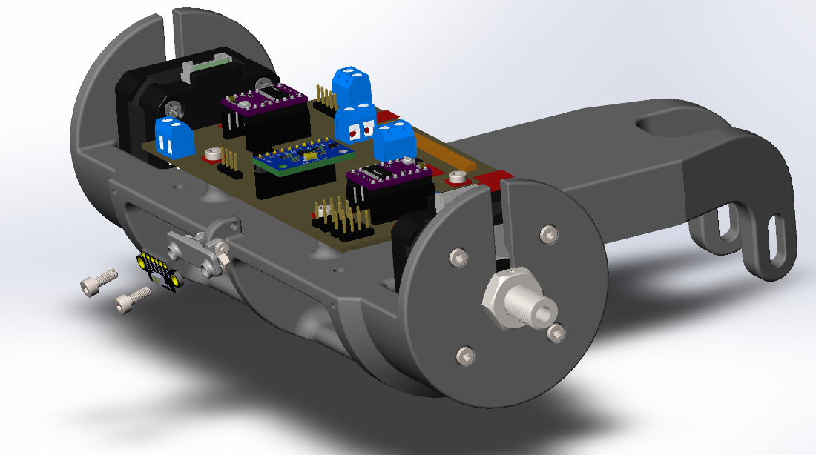Secure the Time Of Flight sensor with 2x M3x8mm screws and nuts on the TimeOfFlightMount

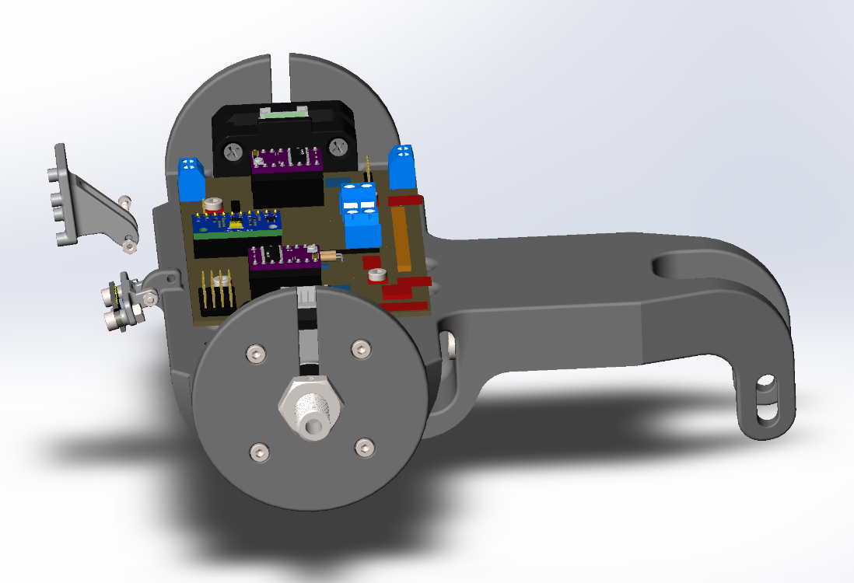

Mount the CameraMount on the upper hole on the front of the middlepart with a M3x12mm screw and nut

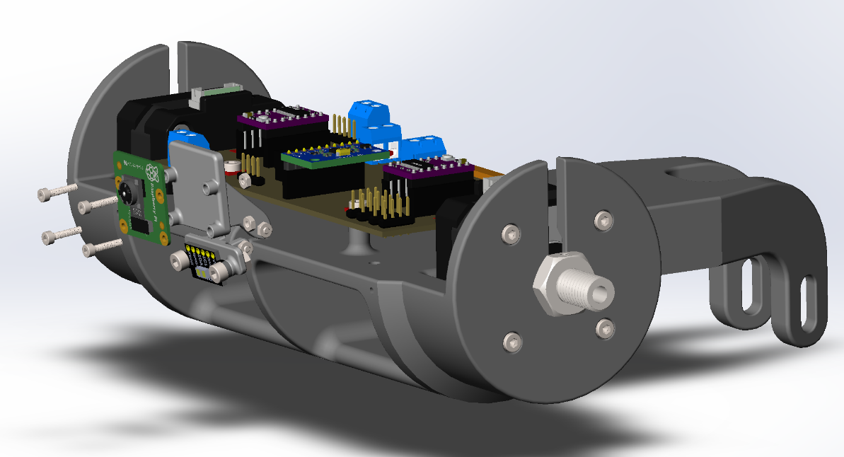

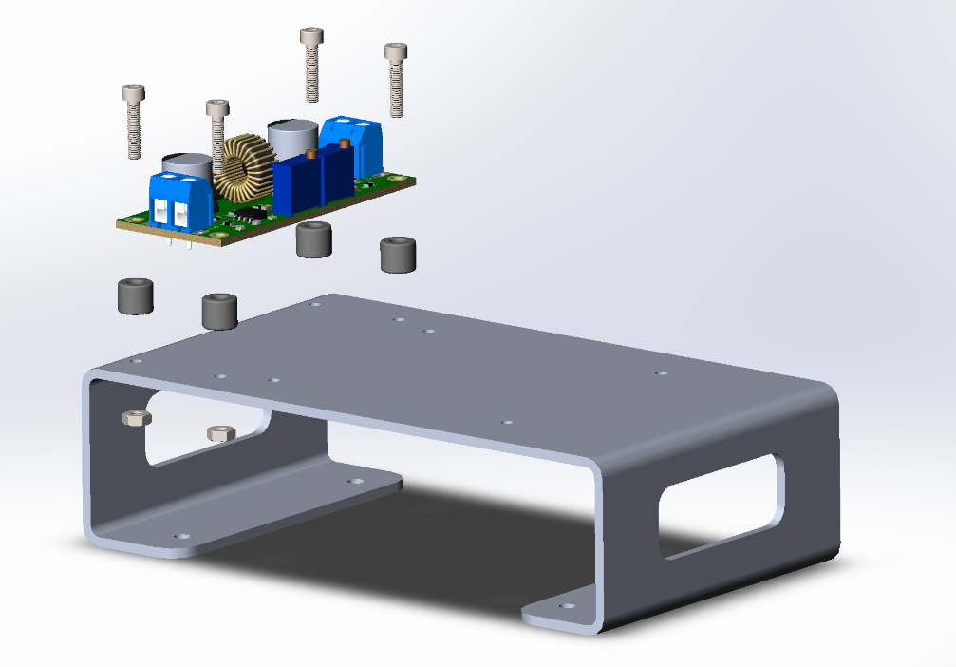Secure the Camera to the CameraMount with 4x M2x6mm screws and nuts. Make sure the flat cable of the camera point to the top of the robot.

Grab the sheet metal 3rdFloor and use 4x spacers + 4x M2.5x12mm screws and nuts the secure the buckconverter.

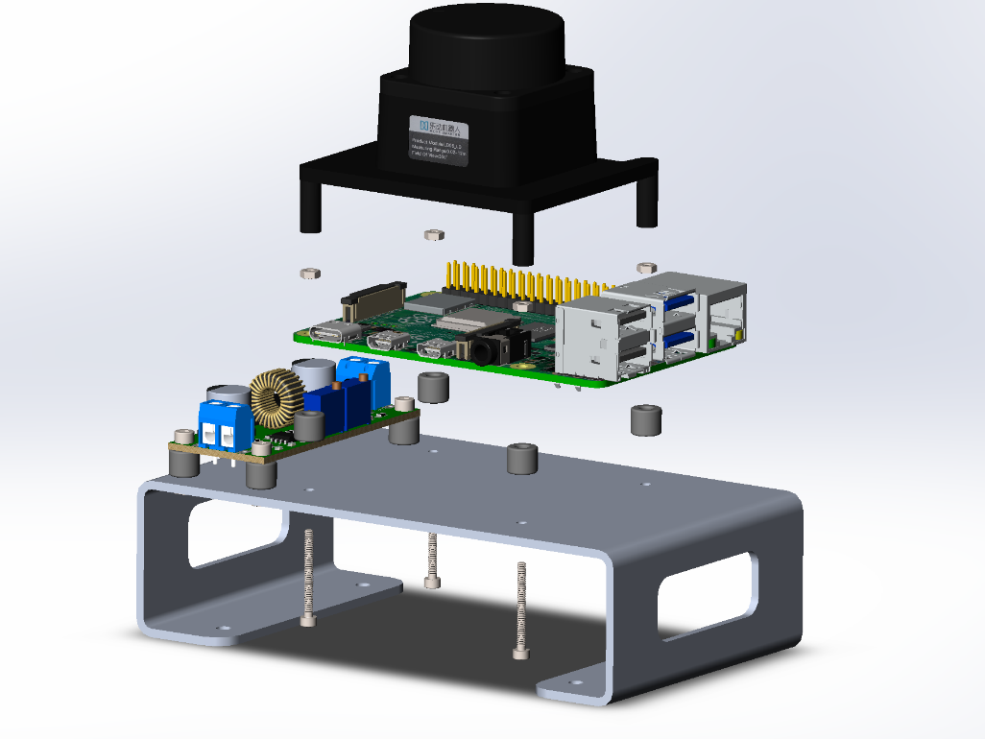Put the Raspberry Pi and lidar onto the sheet metal using 4x spacers + 4x M2x20mm screws and nuts. Before doing this you have to place the 3rdFloor loose on the robot (see next step). Then first attach the Camera flat camera into the Raspberry Pi before securing the lidar on top of it.

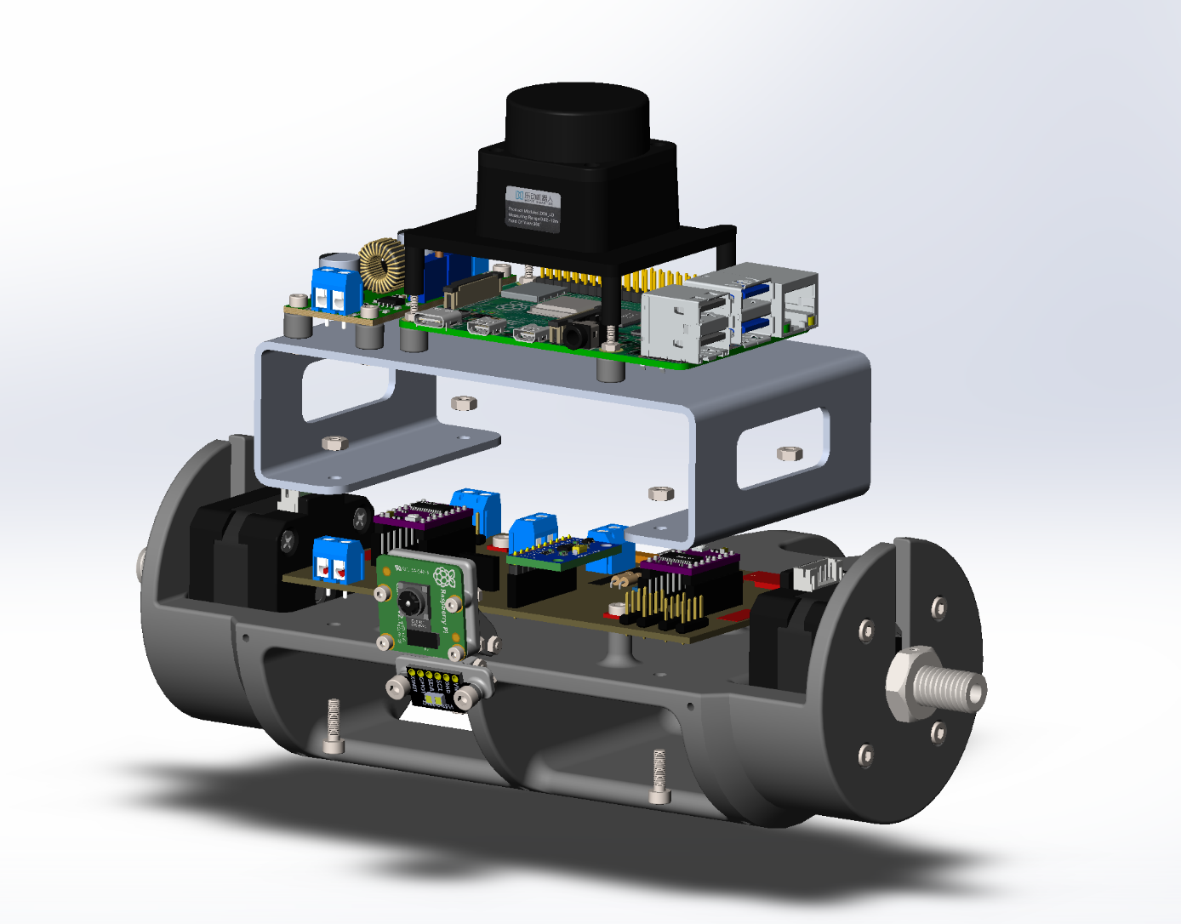Now secure the 3rdFloor with 4x M3x10mm screws and nuts to the middlepart. You have to slide the 3rdFloor under the PCB from the back of the robot to successfully achieve this step.

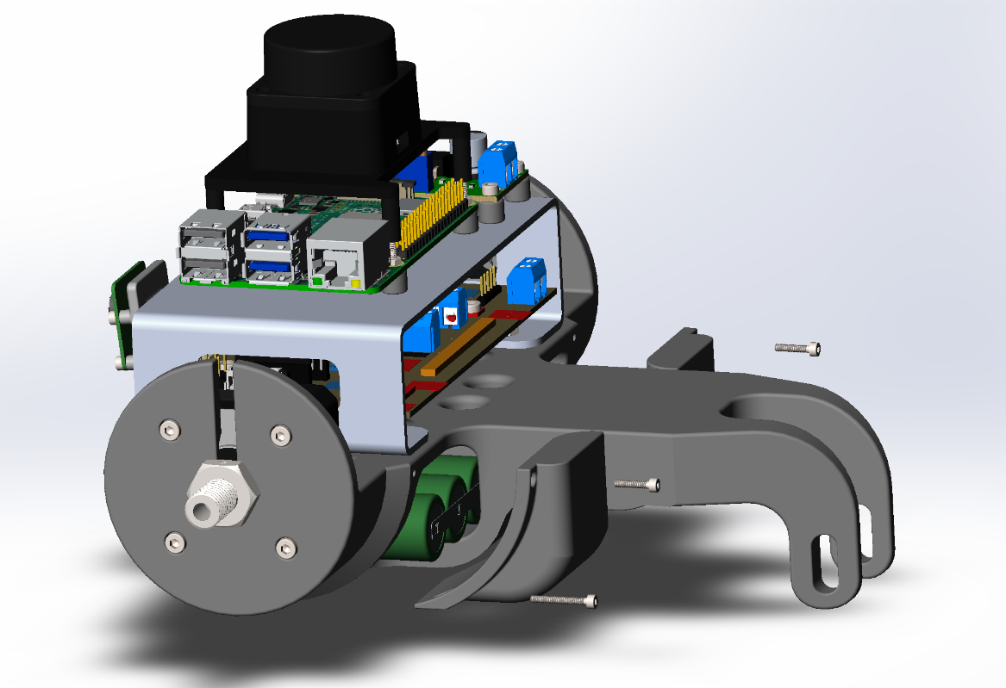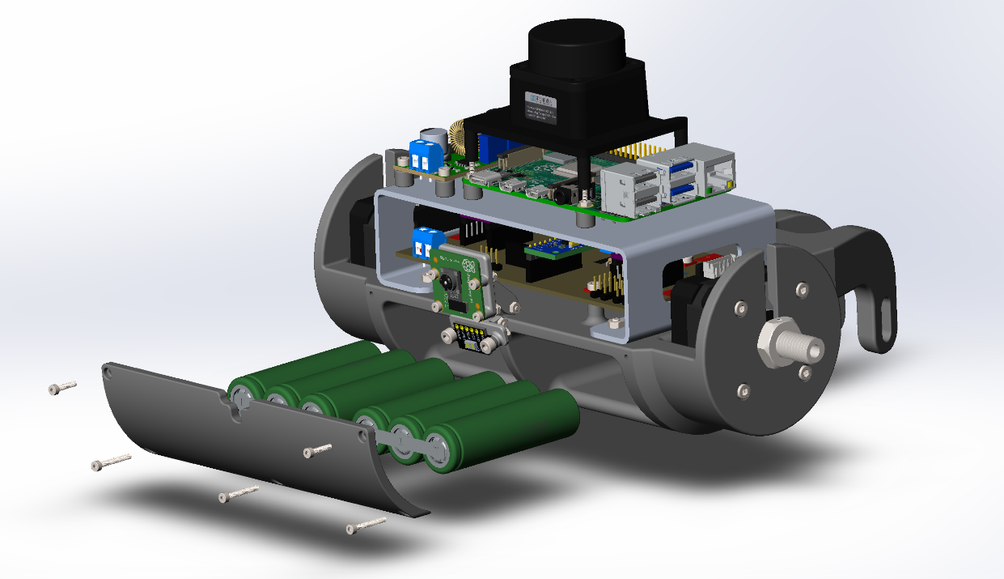Slide the battery packs into the robot. Make sure the cable face the to the front of the robot these need to stick out of the 2 big holes into the back of the middlepart of the robot. Then put on the BatteryFrontCover with 2x M2x10mm and 3x M2x16mm screws

Put the left and right BatteryBackCovers on with either 1x M2x10mm and 1x M2x16mm screw

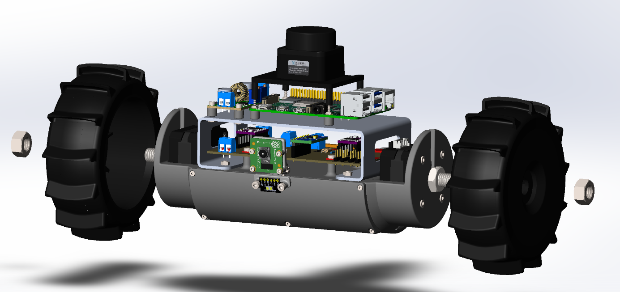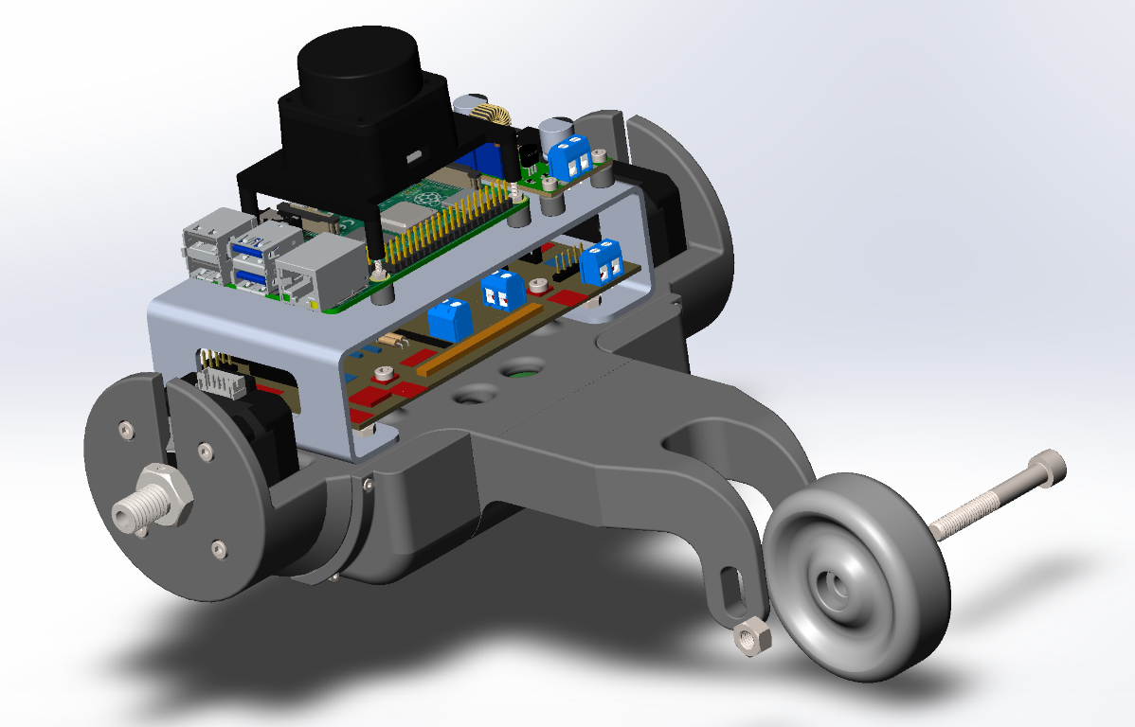Secure the BackWheel on the tailpart with 1x M6x45mm screw and nut

As last mount the left and right buggy wheels with either 1x M10 nut on the axel hubs.

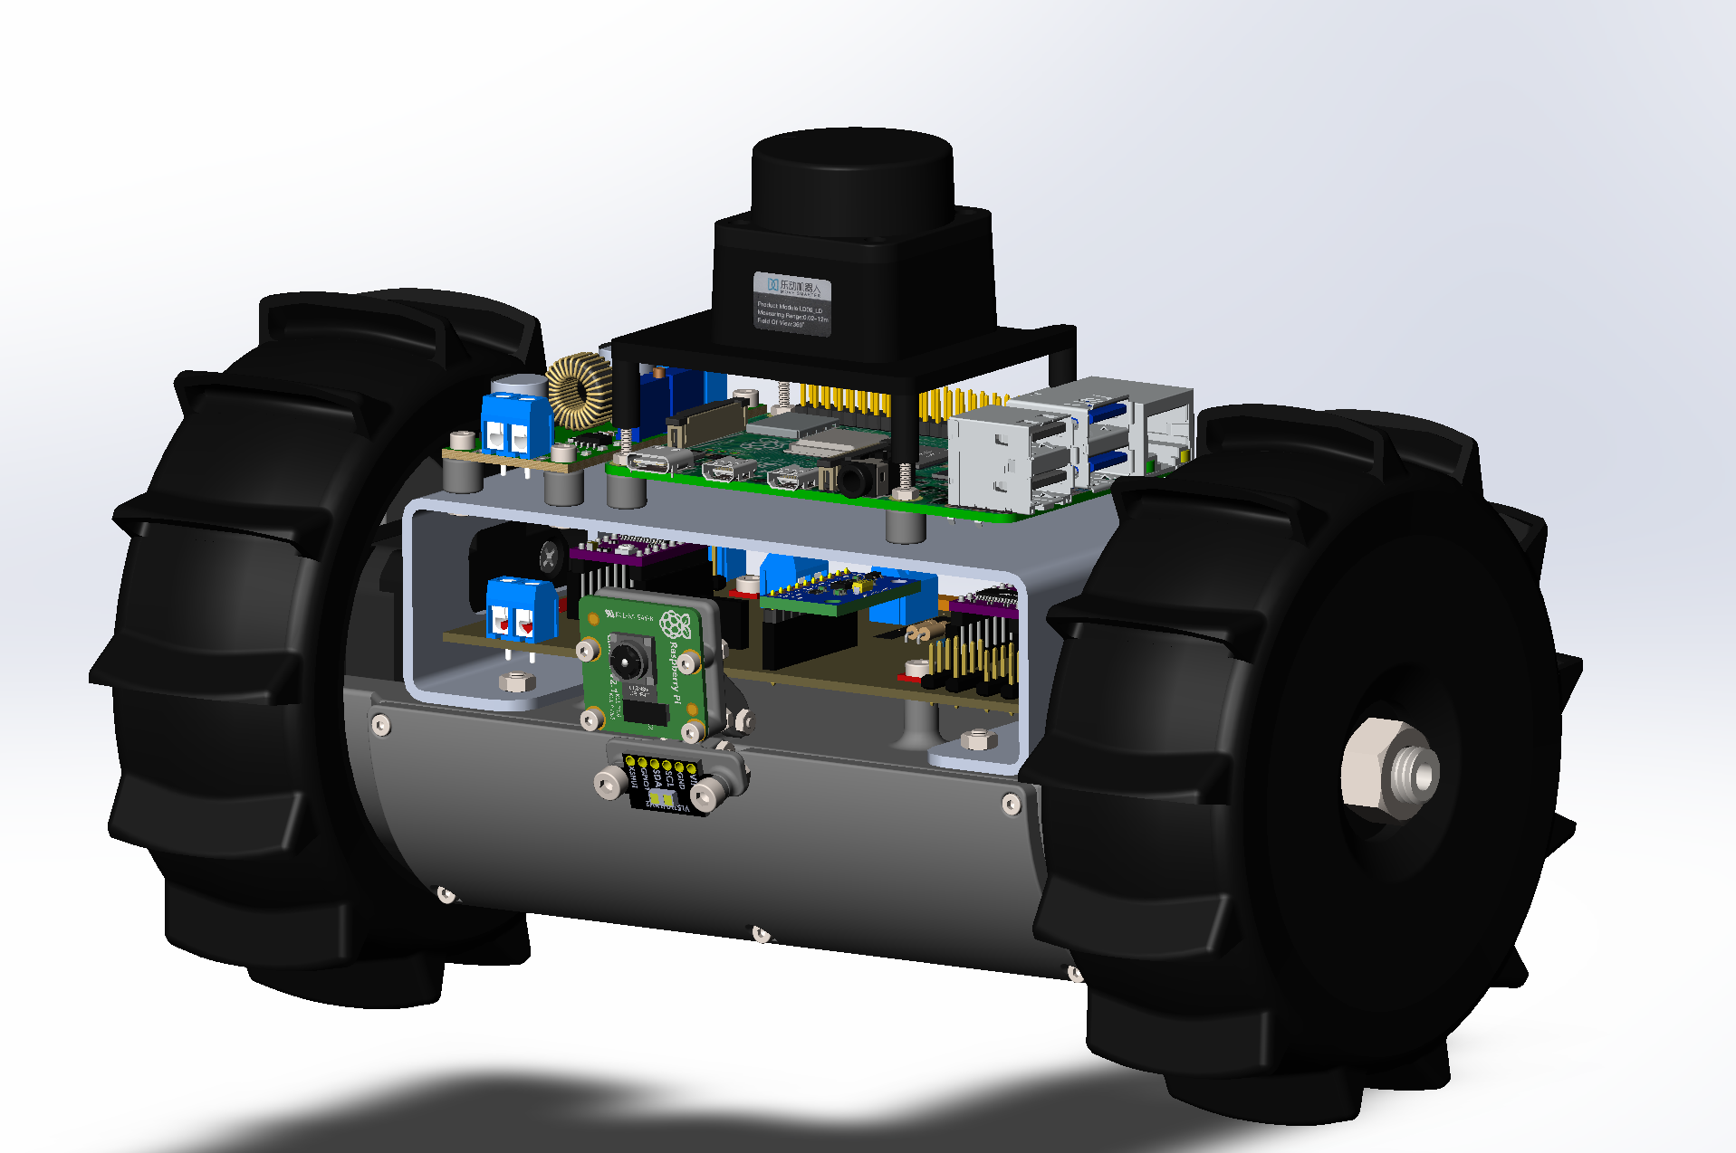Finished!!!

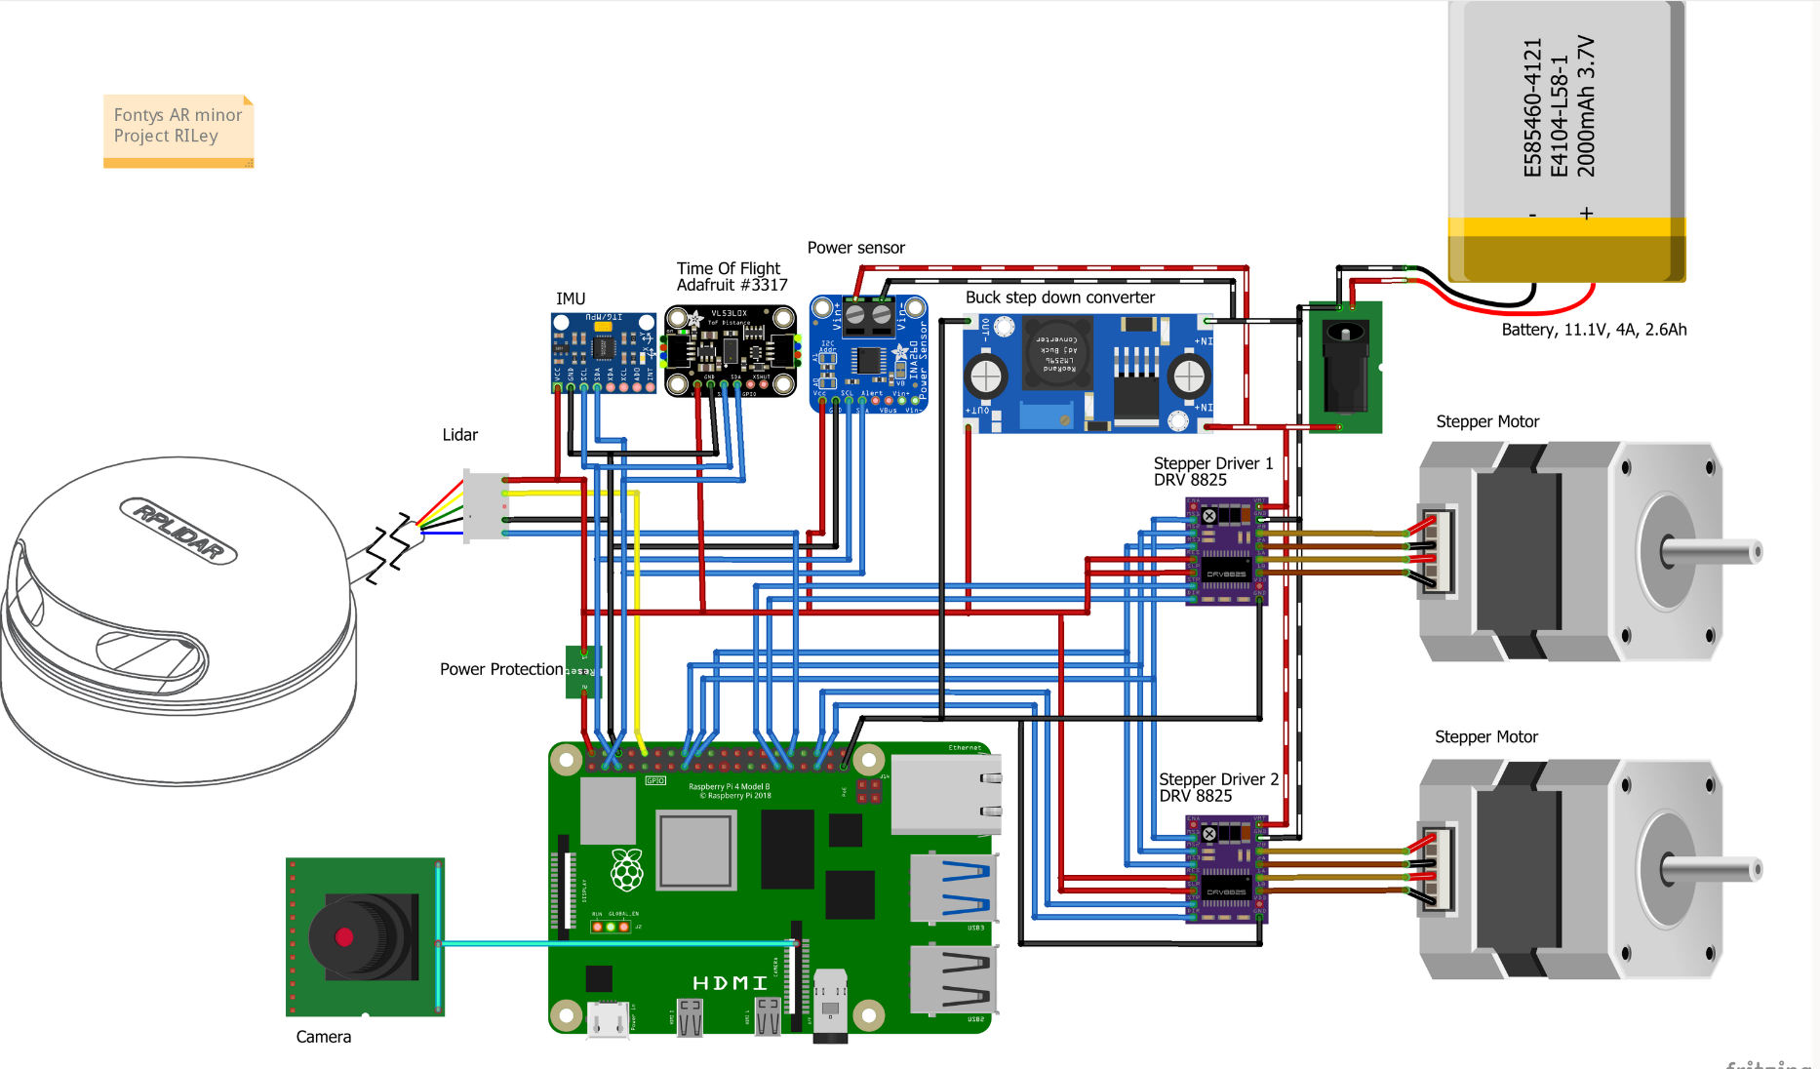**RILey Robot Electrical design**

In the electrical schematic above you can see all the modules that are being used in the RILey and how everything is connected relative to each other. So we have a IMU. This is a module that has multiple sensors: an accelerometer, a gyroscope and a magnetometer. We will be using the accelerometer and gyroscope for feedback of the driving. There is also a Time of Flight sensor. This is used for close object detection or drop/edge detection, so the RILey can save itself and plan a different path. Also on there is a power sensing module, which will be utilised to measure the power consumption and battery status, so that we can act upon a dying battery. We also have a lidar and a camera added, so we can recognize the world in real time.

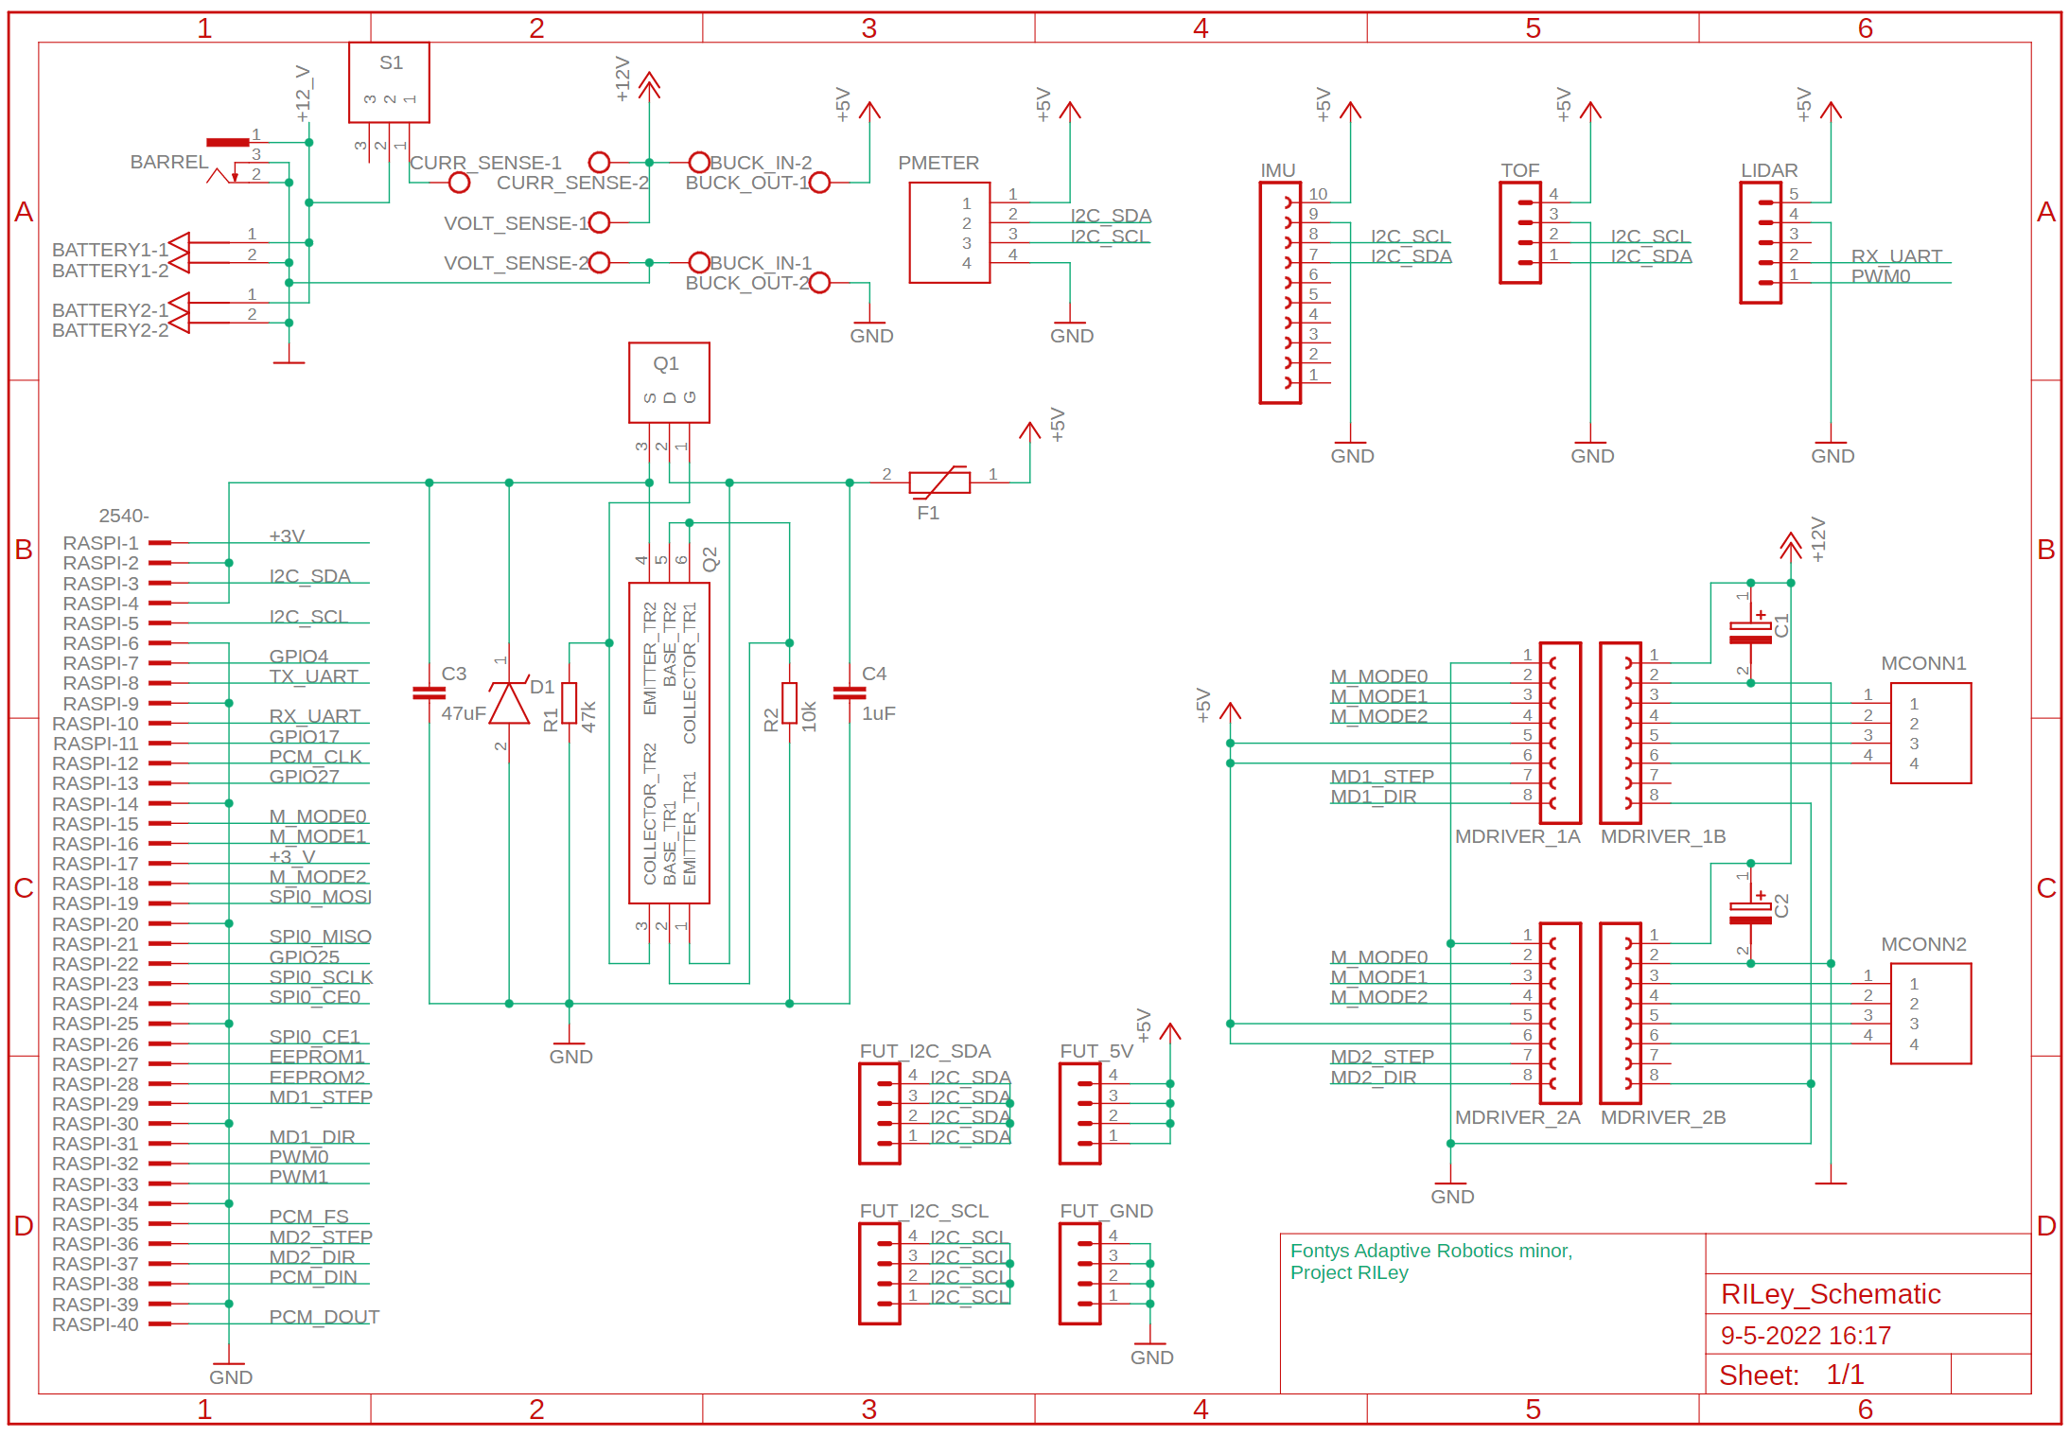This is the schematic of the electronic design used for making the PCB used in RILey.

**Charging instructions**

The robot should be charged using a power supply and the charging cables included in the box of accessories. Use 13.4V @ 2A to normally power the robot, otherwise 13.4V @ 3A, since the batteries should only receive 1A for charging.

**1 Installing Ubuntu core 20.04 on a SSD portable drive (Windows)*doesn’t work yet\***

Here we are going to install Ubuntu on a SSD/USB drive. This way you can use the Ubuntu operating system when you plug in the SSD drive and when you disconnect the drive you can still use your normal Windows OS.

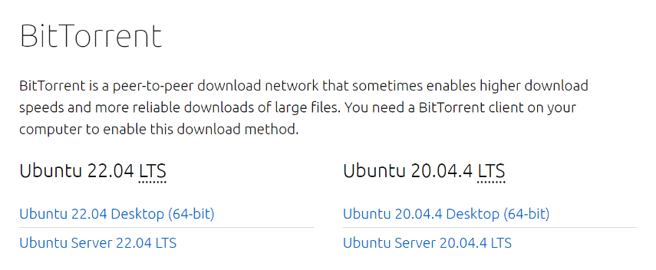First you have to download a Ubuntu OS on the internet using this site: <https://ubuntu.com/download/alternative-downloads> then go to:

Make sure you get the 20.04 version of Ubuntu Desktop. This will download a BitTorrent file which you need a program for to fully download the OS image. I used qBittorrent you can download it here: <https://www.qbittorrent.org/download.php>

Then after you downloaded and installed qBittorrent you have to open your downloaded *Ubuntu 20.04 Desktop (64-bit)* torrent file in there. If the Progress bar reaches a 100% it is done downloading. Check if everything went well without errors or warnings. 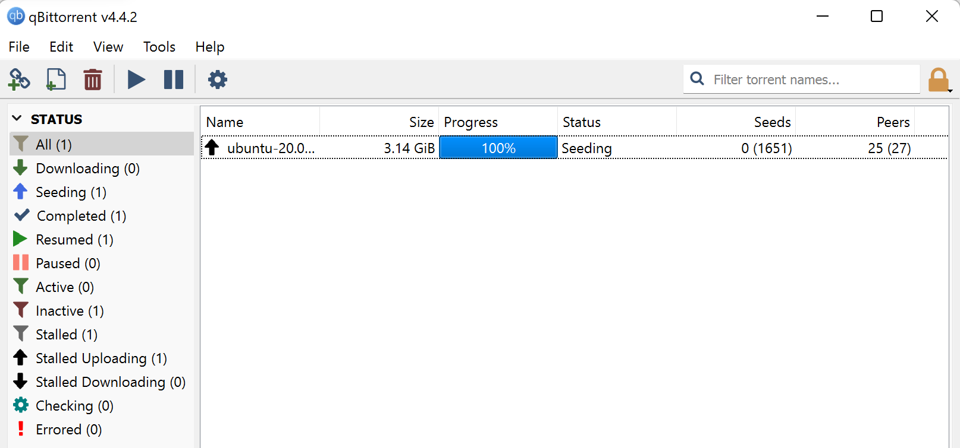

After that you will need a program the reformat the SSD drive. For this I used a program called Rufus. It is extremely easy to use, you can download it here: <https://rufus.ie/nl/>

After you downloaded, installed and launched it you can then choose the SSD device which you want to format. You also need to select the OS image you downloaded with qBittorrent. Set the Partition scheme to “MBR” and the Target system to “BIOS or UEFI”. Make sure the File system is on “Large 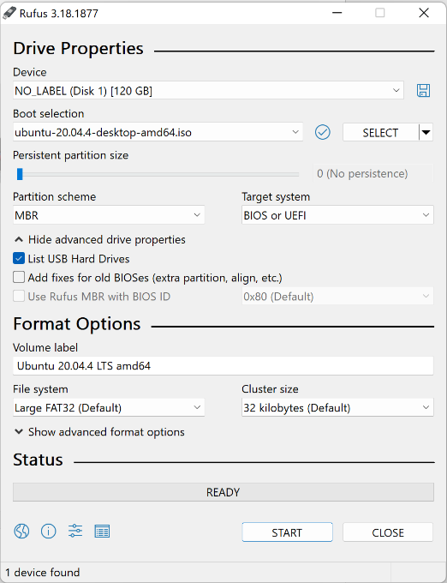FAT32” and Cluster size is on “32 kilobytes”. It should look something like this below.

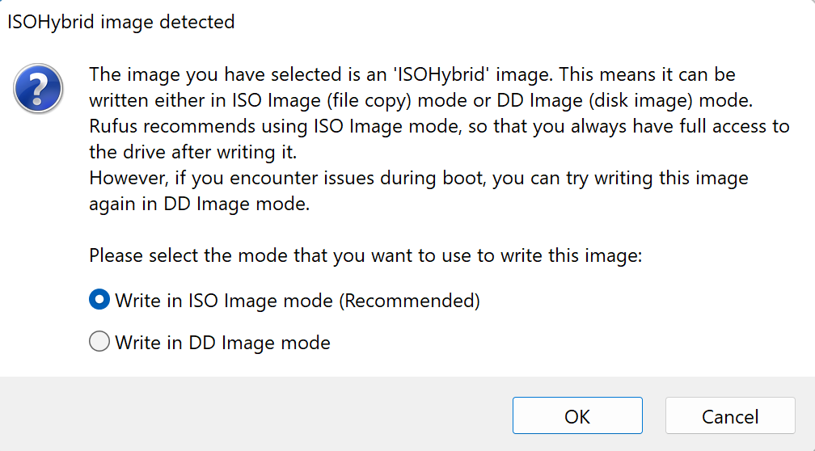After making sure everything is set right you can click on START

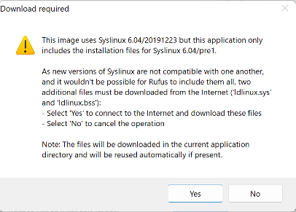There will probably me some warning pop-ups but you can click on OK

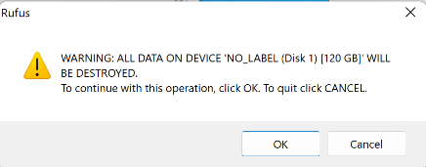Click on Yes

Click on OK

After that is done you can click on close in Rufus and you are ready to boot into the SSD drive.

**2 Installing Ubuntu server 20.04 on your Raspberry Pi**

**2.1 Put an OS image on a SD-card**

First of all you need a raspberry pi 3 or 4 (preferable 4) you also need a micro SD-card with more than 8GB of memory. Stick the empty SD-card in your computer you might need an adapter for this. Here we used the official raspberry pi imager you can download it here. <https://www.raspberrypi.com/software/>

Using the official raspberry pi imager select Operating System è Other general-purpose OS è Ubuntu è Ubuntu Server 20.04.4 LTS (RPi 3/4/400)

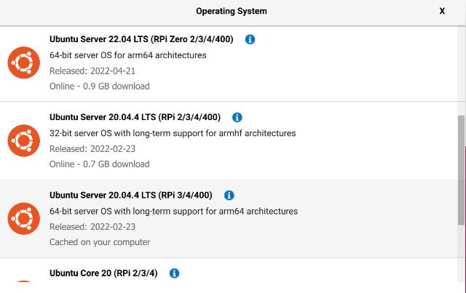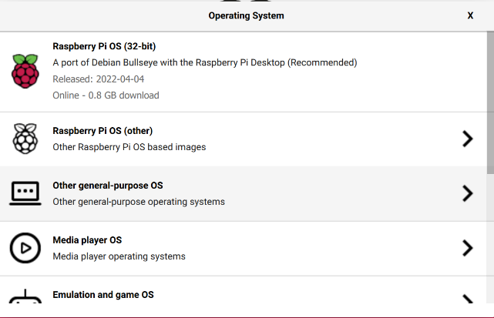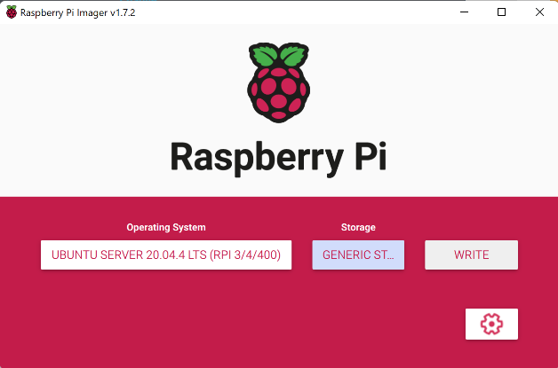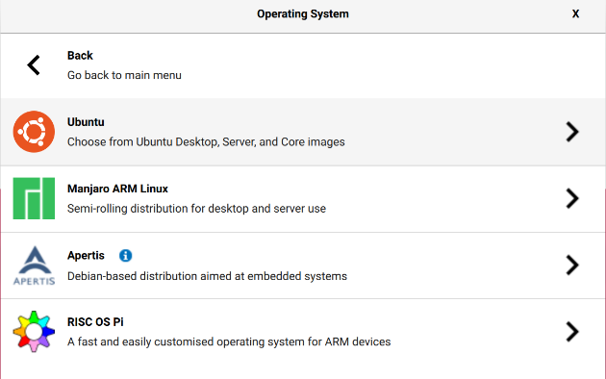

After selecting the OS select a storage device the SD-card and press write to put the OS image on the SD-card. After that’s done you can pull out the SD-card out of your computer and insert it in the raspberry pi. If you plug power into the raspberry pi it should boot up with the new operating system.

**2.2 Configure network setting directly from the SD-card *doesn’t work yet\***

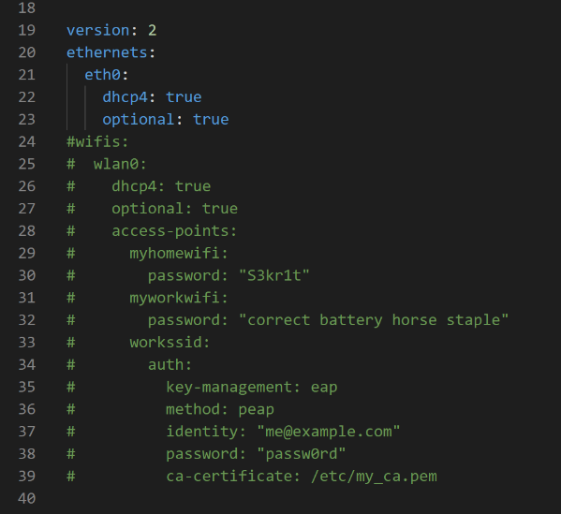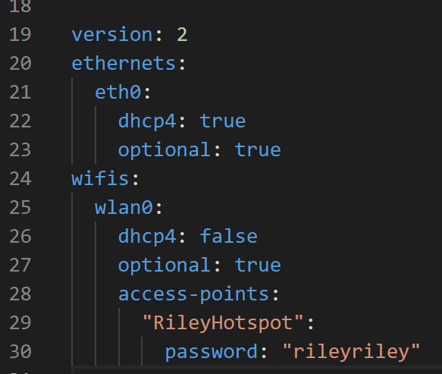When successfully written the OS put the SD-card back in the computer go to “system-boot” to edit a file named “network-config” open this in a text editor. Change this file accordingly so it can find the hotspot you made.

Open table

**2.3 Configure network setting on Raspberry Pi**

To connect your raspberry to a Wi-Fi network you have to log in to your raspberry pi using a monitor and keyboard.

Navigate to netplan

**$ cd /etc/netplan**

Remove the old file 50-cloud-init.yaml

**$ sudo rm 50-cloud-init.yaml**

Add a new file named 01-netcfg.yaml

**$ sudo touch 01-netcfg.yaml**

Edit 01-netcfg.yaml file

**$ sudo nano 01-netcfg.yaml**

it should contain the following information Tip: the file should not contain any tabs. Each jump is 2 spaces long. This file is based on a hotspot with ssid: RileyHotspot password: rileyriley

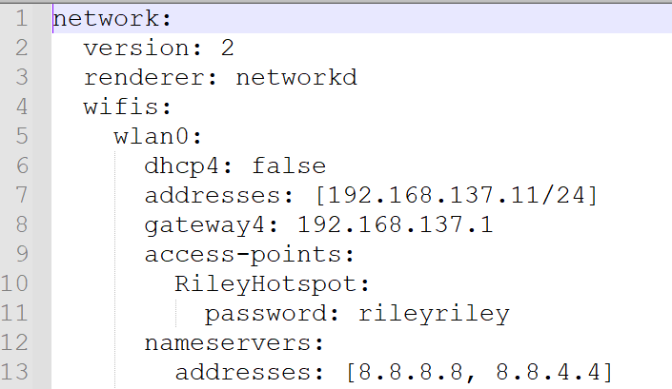

Press control + x then y to save the file and enter to exit out of the nano text editor

Then apply the changes

**$ sudo netplan apply**

In case you run into issues execute: following command to debug

**$ sudo netplan --debug apply**

Next navigate to cloud.cfg.d

**$ cd /etc/cloud/cloud.cfg.d**

Add a file named 99-disable-network-config.cfg

**$ sudo touch 99-disable-network-config.cfg**

Edit file

**$ sudo nano 99-disable-network-config.cfg**

It should contain the following information:

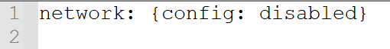

Press control + x then y to save the file and enter to exit out of the nano text editor

Reboot the pi to make sure everything works

**$ sudo reboot**

**2.3 Configure Raspberry Pi itself**

First we set the date and time good. To check this execute command:

**$ date**

If its not good you can set it by running command:

**$ sudo apt update**

You should also change your timezone

**$ timedatectl set-timezone Europe/Amsterdam**

Run again

**$ sudo apt update**

And also upgrade

**$ sudo apt upgrade**

This can take a while, you know when its done if you run sudo apt update and it says that there are no more packages that can be upgraded.

Then after that install ifconfig command tool this is helpful if you want to know the ip-adress of the Raspberry Pi

**$ sudo apt install net-tools**

You also might want to install nmap this is used to scan an ip-range to see which devices are on which ip-adress. To install it run command:

**$ sudo apt install nmap**

To scan an ip-range with a mask of 255.255.255.0 (24-bits) for example 192.168.137.(…) use command:

**$ sudo nmap -sP 192.168.137.0/24**

Here it wil scan all devices that are on the range from 192.168.137.0 and 192.168.137.255

**3 Setting up a local network with static-IP**

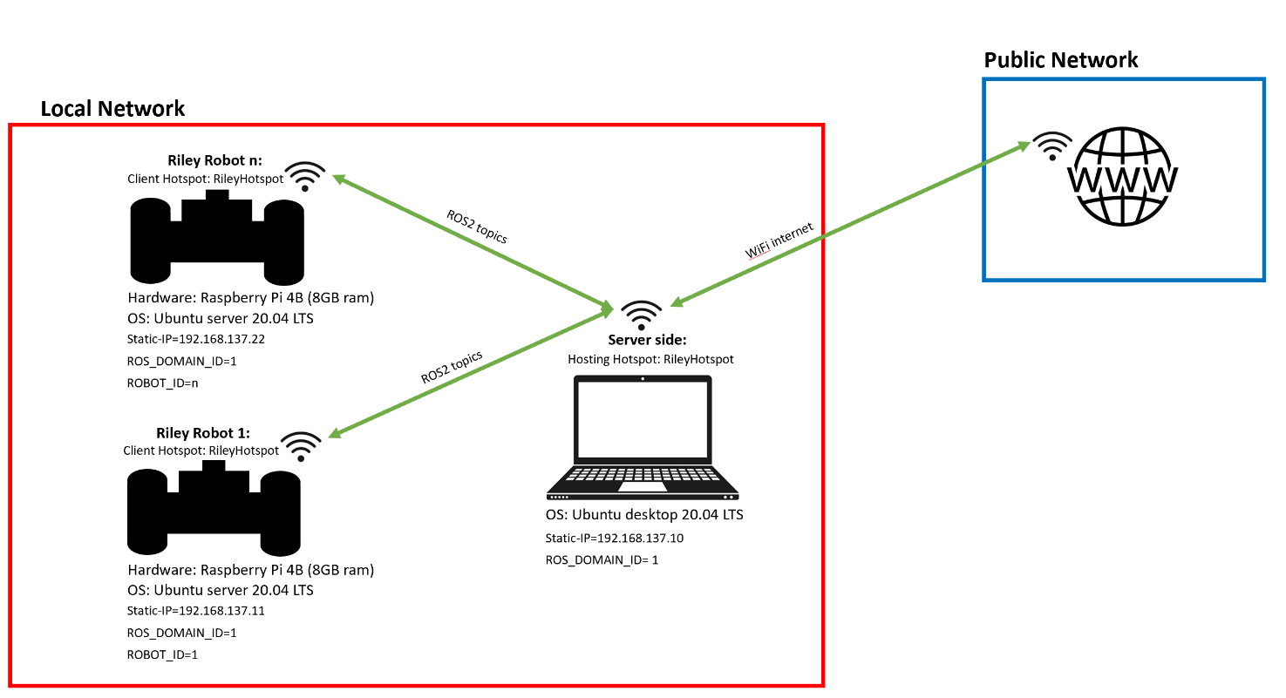**3.1 Network Architecture**

**3.2 Setting up a Hotspot on your PC (Windows)**

Connect your laptop to the internet like normal when you use public websites.

Make a hotspot on your laptop:

1. Go to settings è Network & Internet è Mobile Hotspot

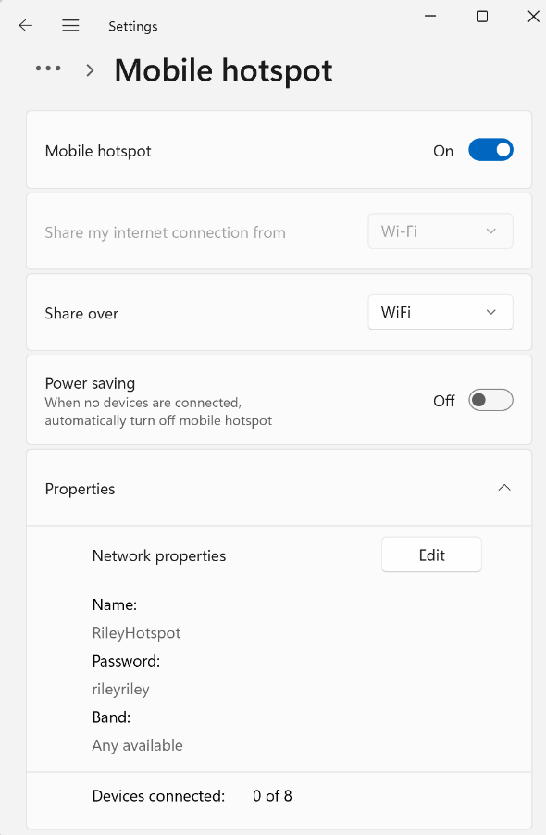put Mobile hotspot On

put Power saving Off

click on Edit Network properties and fill a network name and password in. In this case we will use a Network name: RileyHotspot Network password: rileyriley

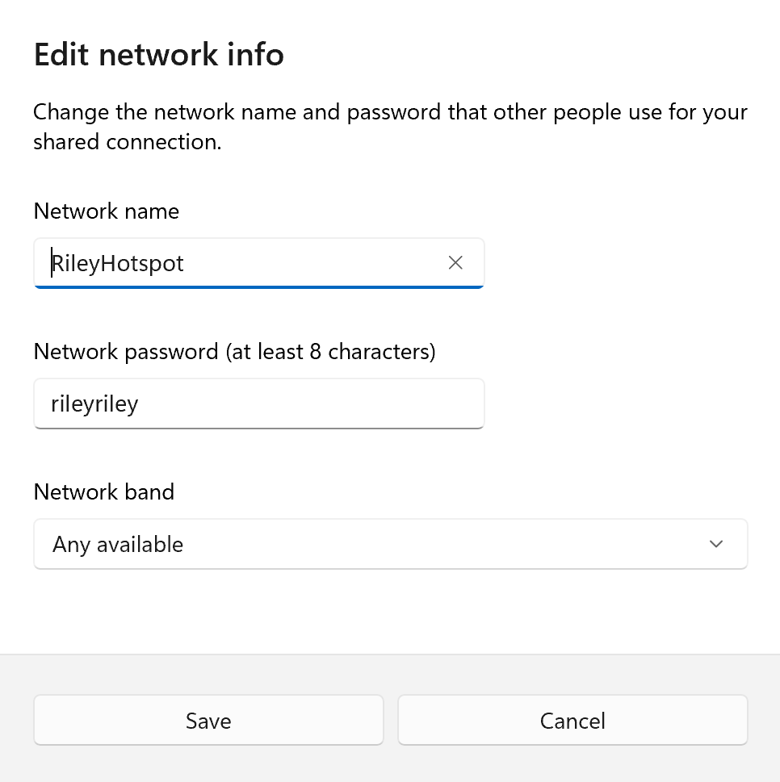click on Save

Now you have made a Hotspot on your PC and you still can use internet because you are also still connected to Wi-Fi network which has internet. Every device that now connects to you Hotspot will also have internet through your PC. This is very useful when you want to install or update packages on the raspberry.

**3.3 Setting up a static IP-address on your PC (Windows)**

1. Go to settings è Network & Internet è Advanced network settings è More network adapter options è

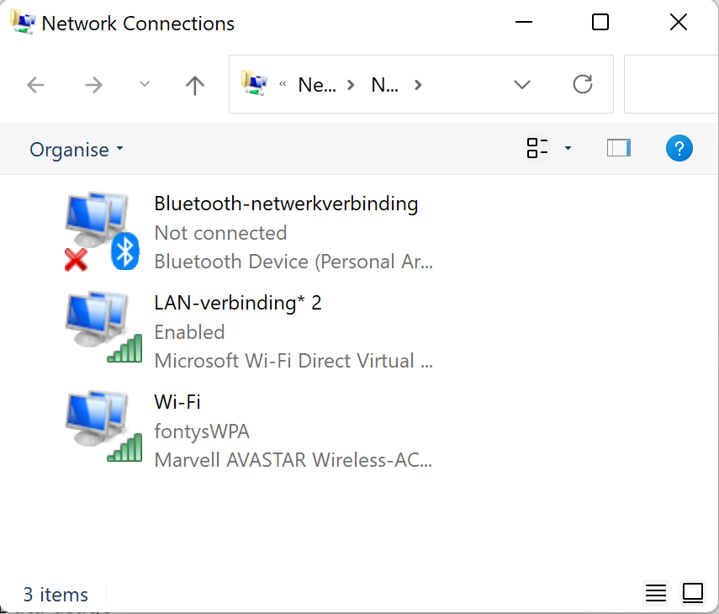

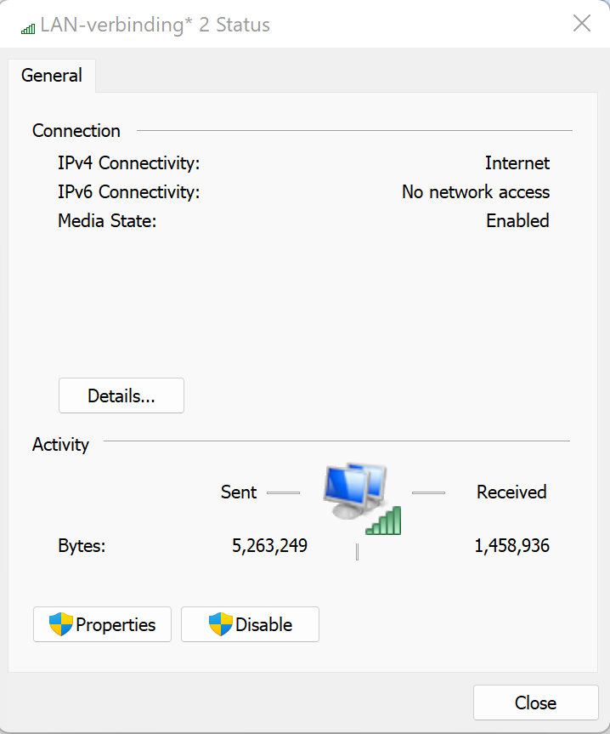

è

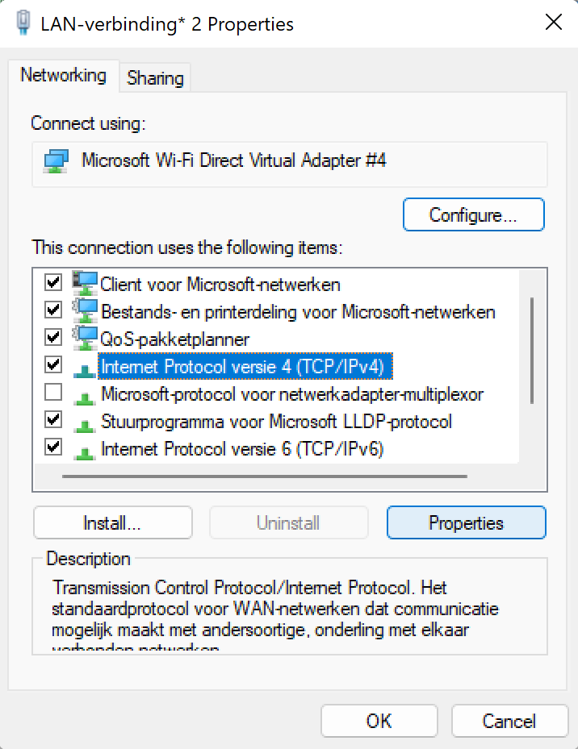Press on LAN-verbinding and then Properties

Here select Internet Protocol versie 4 (TCP/IPv4) properties

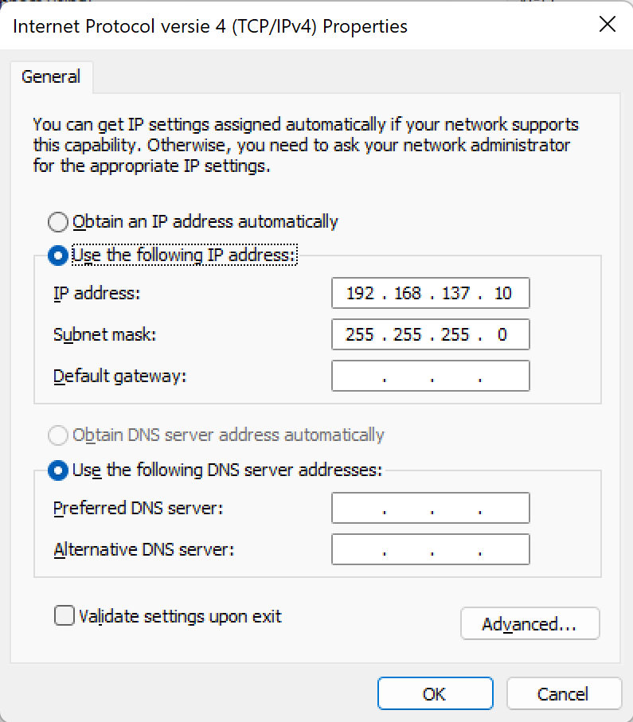

è

Then select Use the following IP address: also you can fill in a IP-address of your choice but make sure there are no multiple IP-addresses the same because that would not work. The subnet mask should be 3 times 255 and 1 time 0. This means 192.168.137 is the locale network and there can be 255 different devices in that same network. After changing make sure you close every window to make the changes take effect.

**4 Connect to the raspberry via ssh (windows)**

**4.1 Use ssh with Command Prompt**

Open Command Prompt and type: ssh ‘username’@’ip-adres’ so in our case we will type:

**> ssh ubuntu@192.168.137.11**

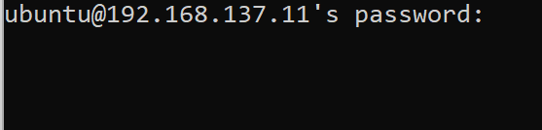

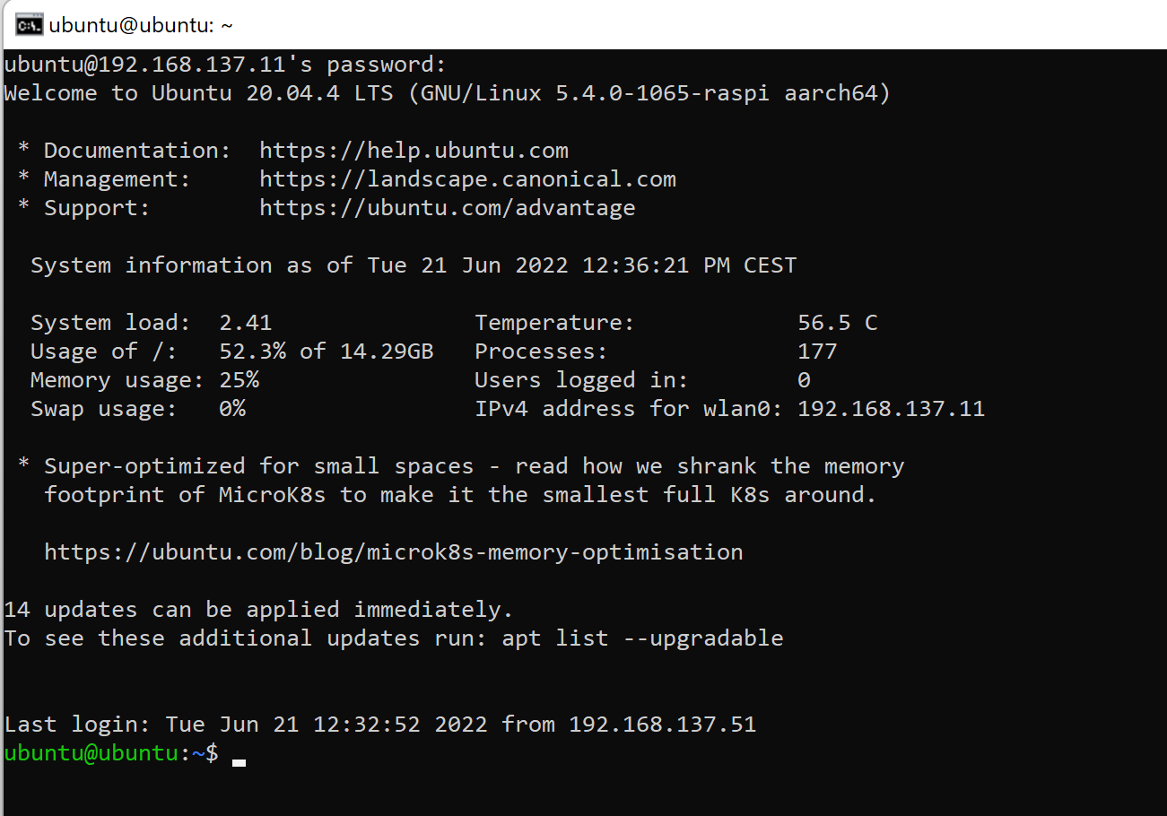Then it will ask for a password, in our case it will be: rileyriley

Now it made successfully a ssh connection between your (Windows) PC and the Raspberry Pi running Ubuntu.

**4.2 Use ssh with Visual Studio Code**

Connecting your PC to the Raspberry Pi with ssh via Visual Studio Code is beneficial for easy development work. You can use the VS Code environment to program the Raspberry Pi without having it installed on there.

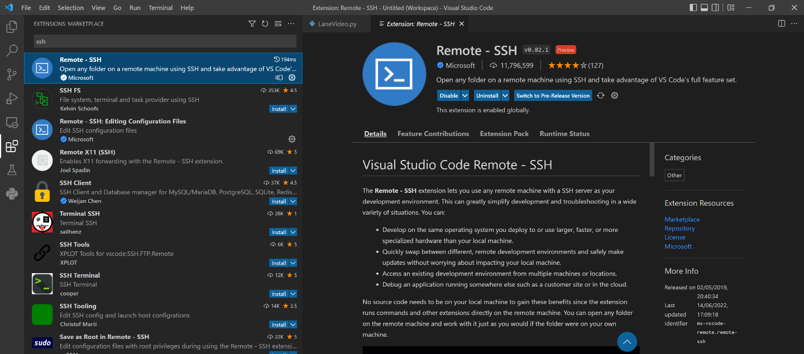First you need to download Visual Studio Code using their website: <https://code.visualstudio.com/> after installing VS Code go to Extensions in the left menu bar or use (Ctrl+Shift+X). Search for Remote-SSH then install that extension see picture below.

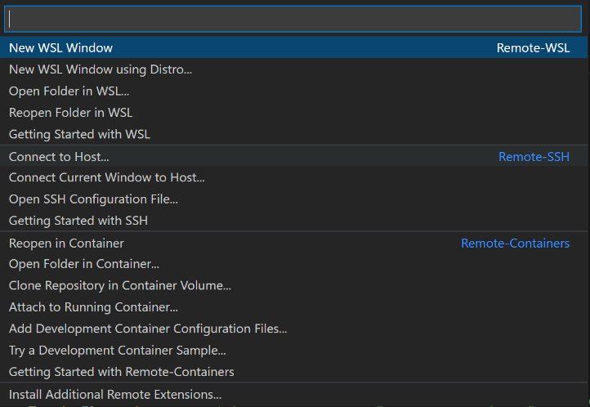After installing the extension using the green button in the left bottom corner or press (Ctrl+Shift+P) to connect to a device

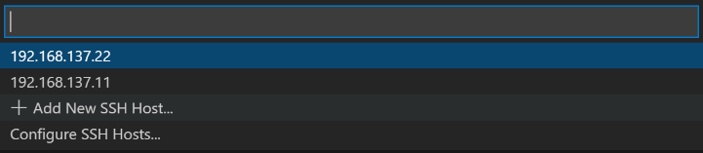Select ‘Connect to Host…’

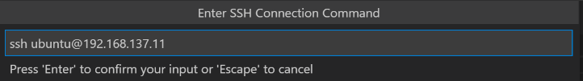If it’s the first time connecting to a new device you can click on: ‘Add New SSH Host…’

There you can enter the username and IP-adress of the device you are trying to connect with in our case this will be ssh ubuntu@192.168.137.11

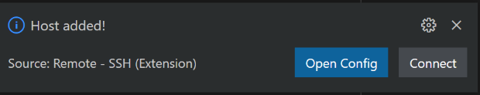After selecting the SSH configuration file to update to you will get a screen that the Host is added

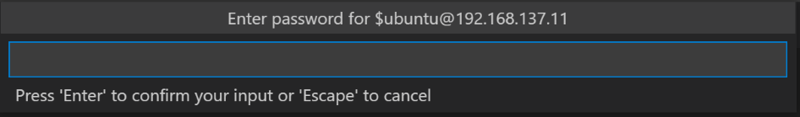Click on Connect.

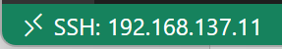Now fill in the password of the device you are trying to connect with. In our case this will be: rileyriley

If you see this green picture on the left bottom of your screen you know you succefully connected.

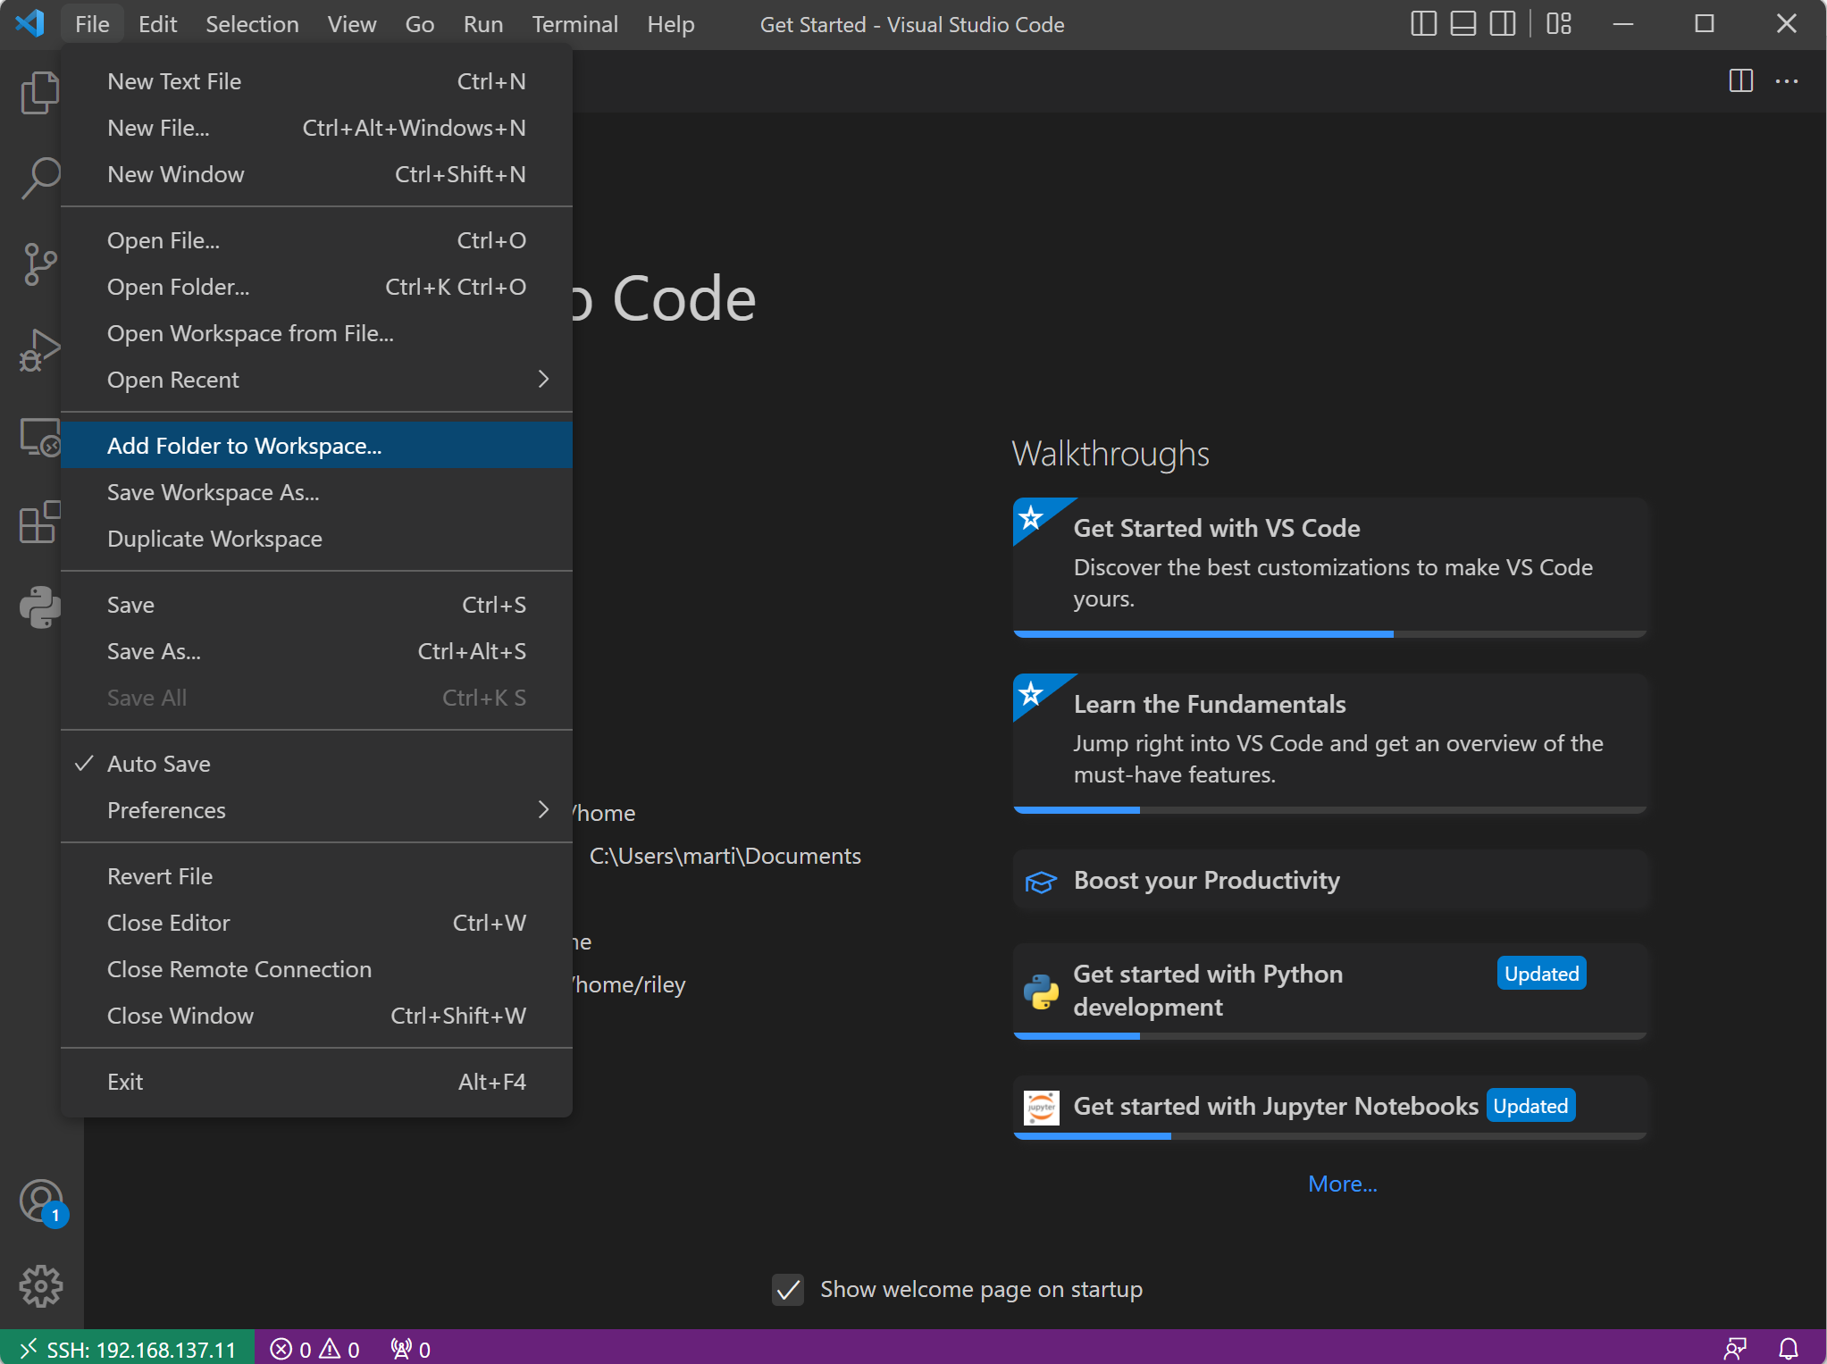

Go to FileèAdd Folder to Workspace… and choose a folder were you like to work from.

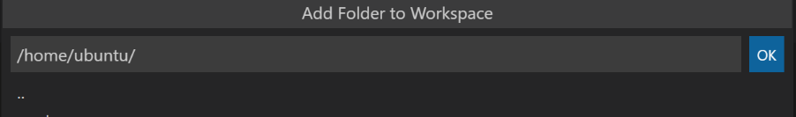

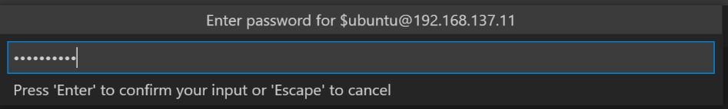Here I choose to work from the ubuntu folder and click on OK.

Fill in the password again.

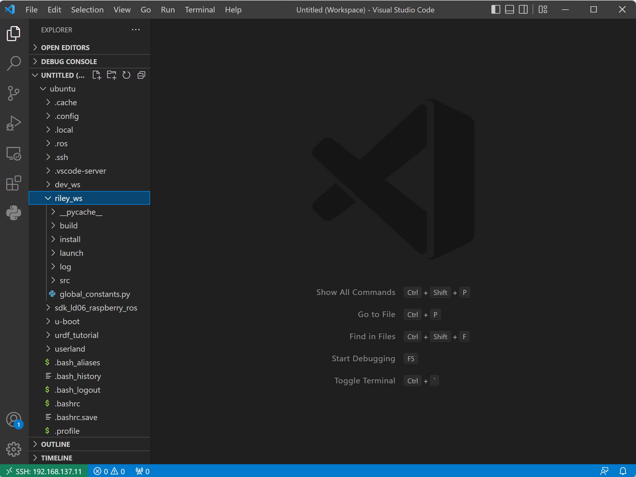

Now you can use VS Code like your used to only now you’re working on the Raspberry Pi.

**5 Setting up the Raspberry pi (Ubuntu server 20.04)**

**5.1 Enabling camera on ubuntu server**

For enabling the camera on ubuntu server

**$ sudo nano /boot/firmware/config.txt**

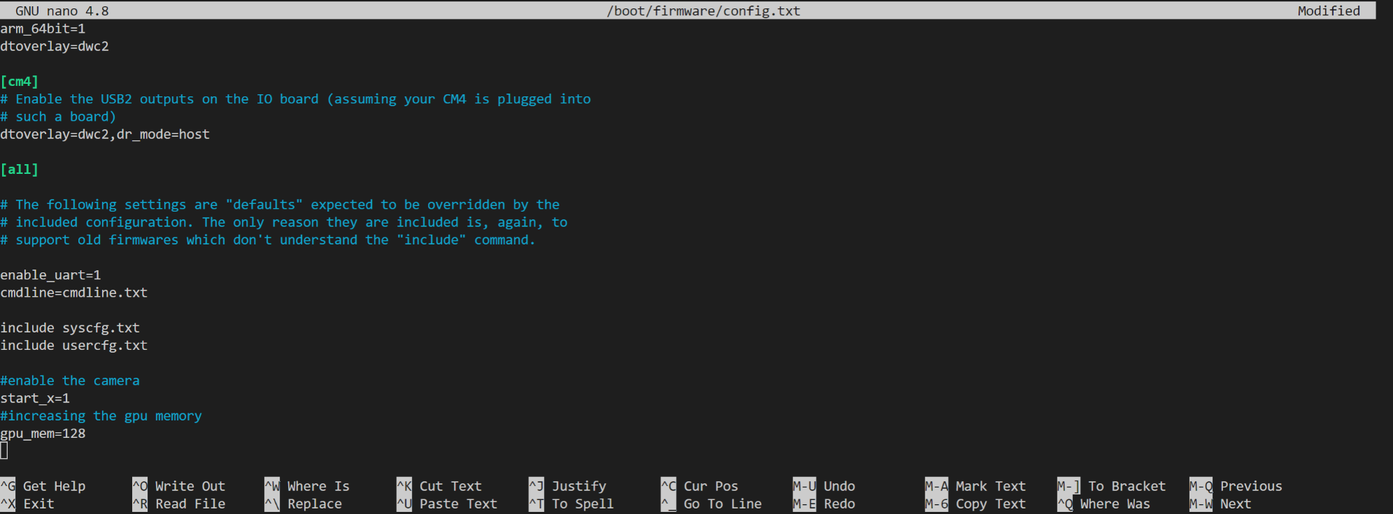Here you write two lines of code on the end of the config.txt so the camera is enabled. To enable the camera write start_x=1 and to increase the gpu memory write gpu_mem=128 like the picture below.

When your done editing press ‘Ctrl + x’ then save with ‘y’ and close with ‘Enter’

Then reboot the system using command:

**$ sudo reboot**

You can check if the camera is enabled with going to /dev

**$ cd /dev**

Then list what is in the directory

**$ ls**

Then check if you can see video0 in there. If you can see it than the camera works! You can easily verify with making a photo and save it in a file with a simple python script.

**5.2 Installing ROS2 on your Raspberry Pi**

Tutorial used: <https://roboticsbackend.com/install-ros2-on-raspberry-pi/>

Before installing ROS2 make sure you correctly installed ubuntu server 20.04 and have also installed all the updates for it (see “Installing Ubuntu server 20.04 on your Raspberry Pi”).

If you are ready to install ROS2 on your Raspberry Pi you should start with setting up the locale by executing the following commands in order:

**$ sudo apt update && sudo apt install locales**

**$ sudo locale-gen en_US en_US.UTF-8**

**$ sudo update-locale LC_ALL=en_US.UTF-8 LANG=en_US.UTF-8**

**$ export LANG=en_US.UTF-8**

Then setup the sources

**$ sudo apt update && sudo apt install curl gnupg2 lsb-release**

**$ sudo curl -sSL https://raw.githubusercontent.com/ros/rosdistro/master/ros.key -o /usr/share/keyrings/ros-archive-keyring.gpg**

**$ echo "deb [arch=$(dpkg --print-architecture) signed-by=/usr/share/keyrings/ros-archive-keyring.gpg] http://packages.ros.org/ros2/ubuntu $(source /etc/os-release && echo $UBUNTU_CODENAME) main" | sudo tee /etc/apt/sources.list.d/ros2.list > /dev/null**

Then update everything once more

**$ sudo apt update**

Next we will be installing ros foxy distribution. Because we are running a headless operating system on the raspberry we will be installing ros-foxy-ros-base this will not contain any GUI tools like RVIZ or Gazebo.

Now you can install ROS2 by running the following command:

**$ sudo apt install ros-foxy-ros-base**

This will probably take a minute to install…

Next we will need to install colcon build. This is used to build your ROS2 packages you made and it is not automatically installed. To install it use:

**$ sudo apt install python3-colcon-common-extensions**

After that ROS2 will have a lot of command line tools. To make speed up the process of developing we will install python module named argcomplete so you can auto-complete in de command line. But make sure you have installed pip3 first, use:

**$ sudo apt install python3-pip**

**$ sudo pip3 install argcomplete**

Now you have installed everything you need to use ROS2 on the Raspberry Pi but you will need to source the ROS2 installation in your environment each time you open a new terminal. Because this is too much work do to you can add the following line to your bashrc

**$ echo "source /opt/ros/foxy/setup.bash" >> ~/.bashrc**

Now you will automatically source the ROS2 installation in your environment if you open a new terminal.

**6 Initializing the LiDAR sensor LD06**

For initializing the lidar we followed the Development Manual on the site: <https://www.ldrobot.com/download/en/98> Make sure you follow the ROS2 tutorial.

**6.1 Communication Architecture**

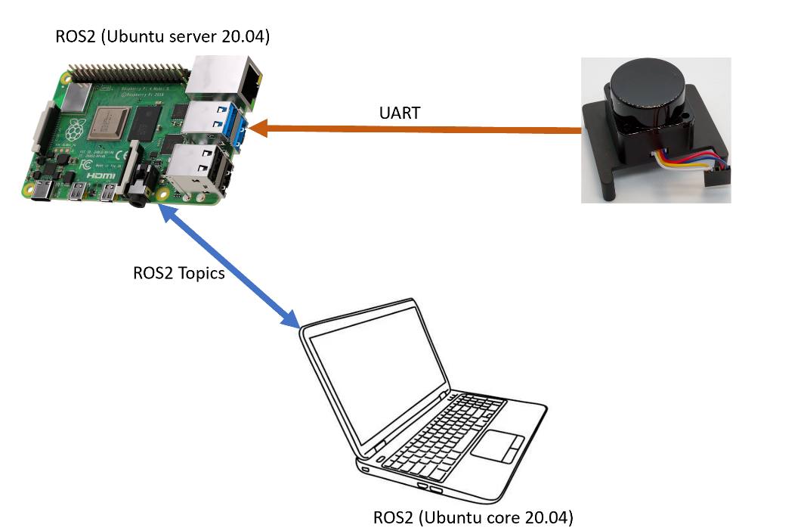

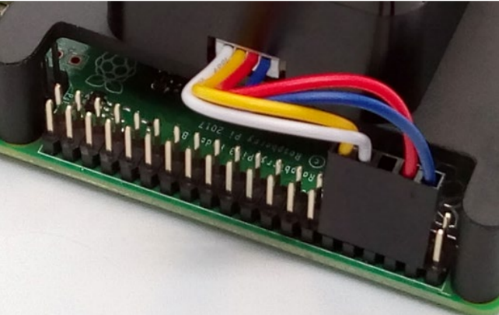First make sure you connect the LiDAR to UART pins on the Raspberry Pi and 5V + Ground (for example) è

**6.2 Installing LiDAR software on Raspberry Pi**

Note: you will need to be connected to the internet for this to work

Connect your PC to your Raspberry Pi using ssh see(…….) or you also can do it directly on your Raspberry Pi using keyboard and monitor. Check if you have a git tool installed if not use this command below:

**$ sudo apt-get install git**

First of all go to the home directory using this command:

**$ cd**

Then make a ROS2 workspaces

**$ mkdir ldlidar_ws**

Go into the ldlidar_ws workspace

**$ cd ldlidar_ws**

In there make also a src directory

**$ mkdir src**

In the src directory clone the following github project

**$ git clone https://gitee.com/ldrobotSensorTeam/ldlidar_stl_ros2.git**

Now we need to set the device permissions. First check if the device is detected by executing:

**$ ls /dev/ttyS0**

This will list every media connection. Then if the UART port is detected change the permissions by executing:

**$ sudo chmod 777 /dev/ttyS0**

After that you have to modify a file. Go to ldlidar_wsèsrcèldlidar_stl_ros2èlaunchèld06.launch.py here we have to change line 9 and 45 so it will say /dev/ttyS0 normally the default is ttyUSB* and that’s fine if you use the USB adapter board but we are using the UART protocol.

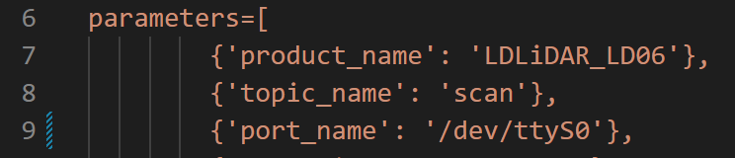

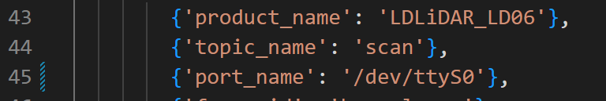

Now everything is set and we can build the package. Navigate to the workspace

**$ cd ~/ldlidar_ws**

Then build the package

**$ colcon build**

After building the package it needs to be sourced

**$ . install/setup.bash**

Now you can run the ld06.launch.py module which will gather the data from the lidar and spit it out. You can run this on the Raspberry Pi then if you can subscribe with your PC on to the laser topic you can visualize the data from the lidar. You can follow the tutorial below here on how to do that.

**6.3 Installing Visualisation software on PC**

In your PC running Ubuntu make sure you installed ROS2 with the GUI tools RVIZ2. We are going to use RVIZ2 to visualize the data of the lidar sensor. To do that RVIZ2 needs to know how to interpretate the data and therefore we need to download a package.

Basically you do the same steps on the PC as you did on the Raspberry Pi. Go to the home directory using this command:

**$ cd**

Then make a ROS2 workspaces

**$ mkdir ldlidar_ws**

Go into the ldlidar_ws workspace

**$ cd ldlidar_ws**

In there make also a src directory

**$ mkdir src**

In the src directory clone the following github project

**$ git clone https://gitee.com/ldrobotSensorTeam/ldlidar_stl_ros2.git**

Then go back to your lidar workspace

**$ cd ~/ldlidar_ws**

And build the package

**$ colcon build**

After successfully build the package you need to source it

**$ . install/setup.bash**

Launch RVIZ2

**$ rviz2**

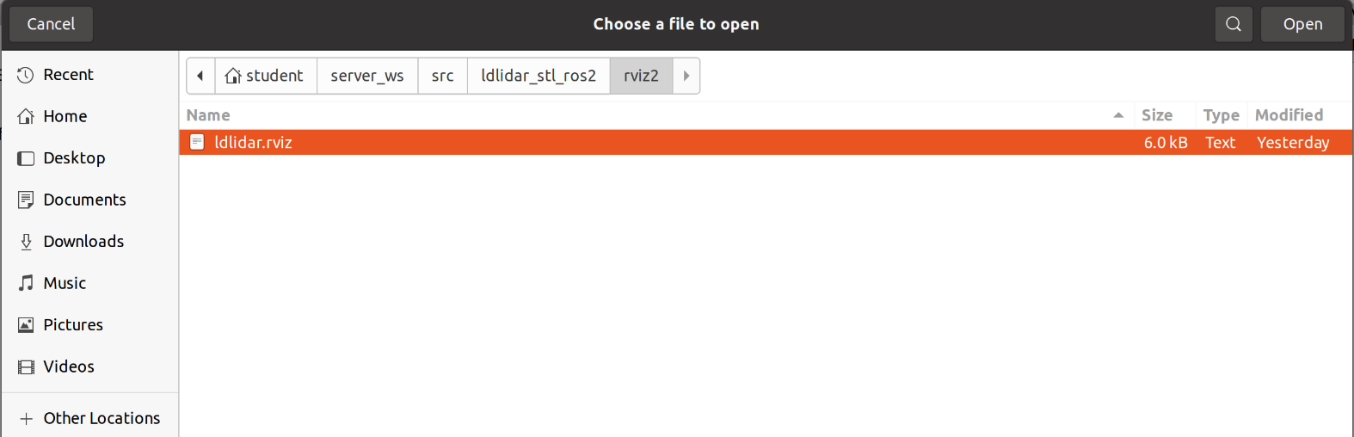After RVIZ2 is started go in the menu bar to fileèopenèConfig In the home folder were you made the ldlidar_wsèsrcèldlidar_stl_ros2==>rviz2 and select ldlidar.rviz and click on open.

After clicking on open you will probably get an message like this

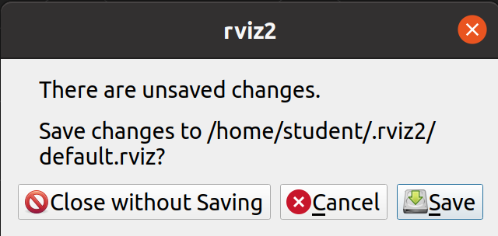

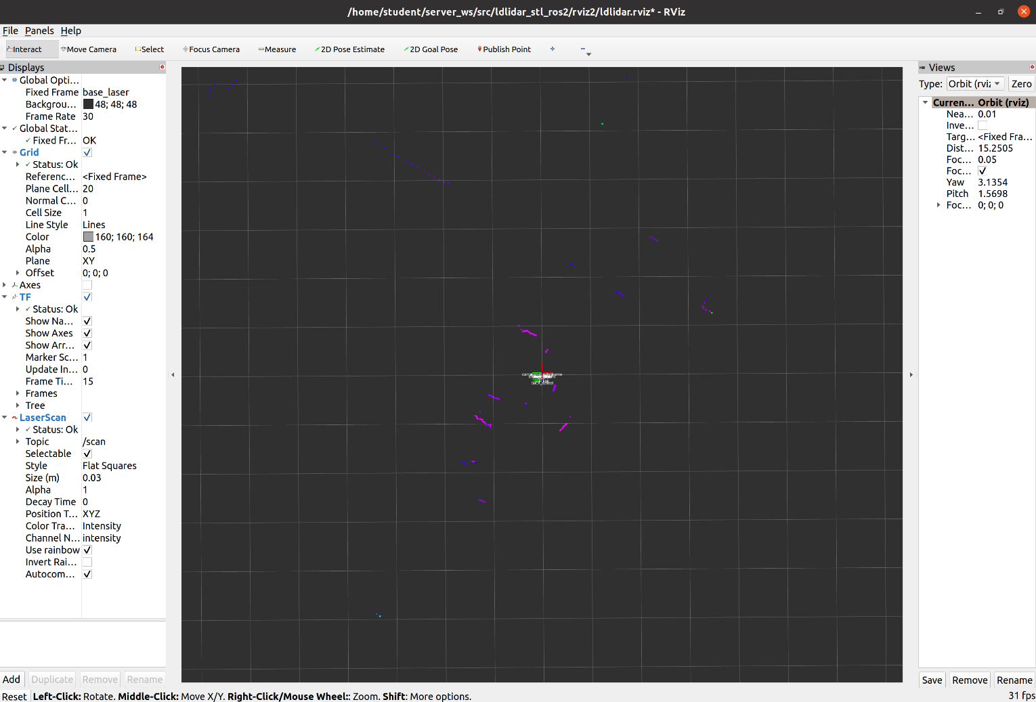If there wasn’t anything important showing up in rviz2 when you started it you can click on Close without Saving.

Now you should see the data of the lidar in rviz2.

**7 ROS2 environment**

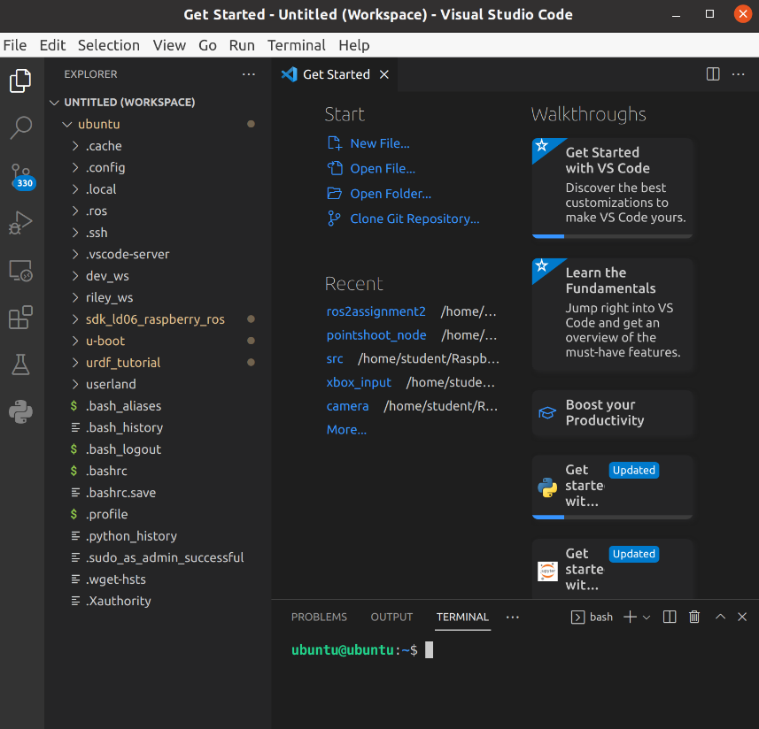When you log into the Raspberry Pi of the RILey robot and open the folder ‘ubuntu’ you will see all the folders and files on left side of the screen.

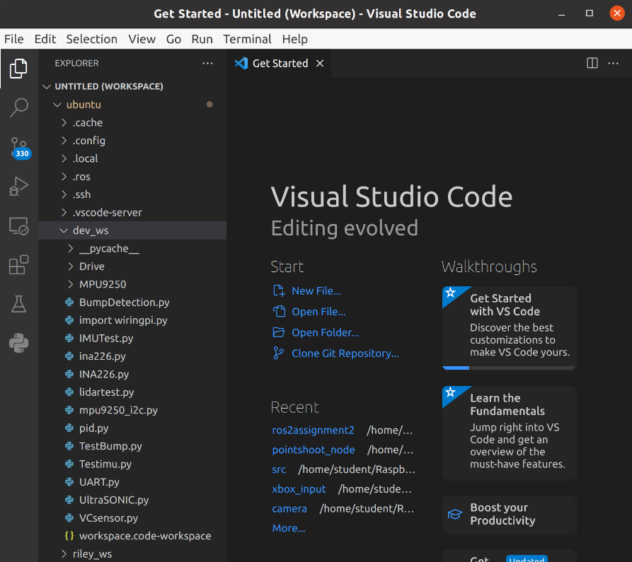Here we have 2 important folders where our work is located. We have the “dev_ws” it stands for development workspace and we used it for developing the riley robot functions. In there we have python scripts which we used for testing the sensors and prototype some algorithms. You can see we have 2 folders in there one “Drive” folder used for testing some driving and one “MPU9250” used for testing the IMU sensor. Also, there are some scripts where we tested different sensors like the Time-of-Flight sensor. Furthermore, we do not actually use any of these scripts on the riley robot but if you want to test something quick you can do it in this workspace.

The “riley_ws” is the most important one, this is a ROS2 workspace and contains all the ROS2 packages we use for making the riley robot operational. In there you can see 2 important directories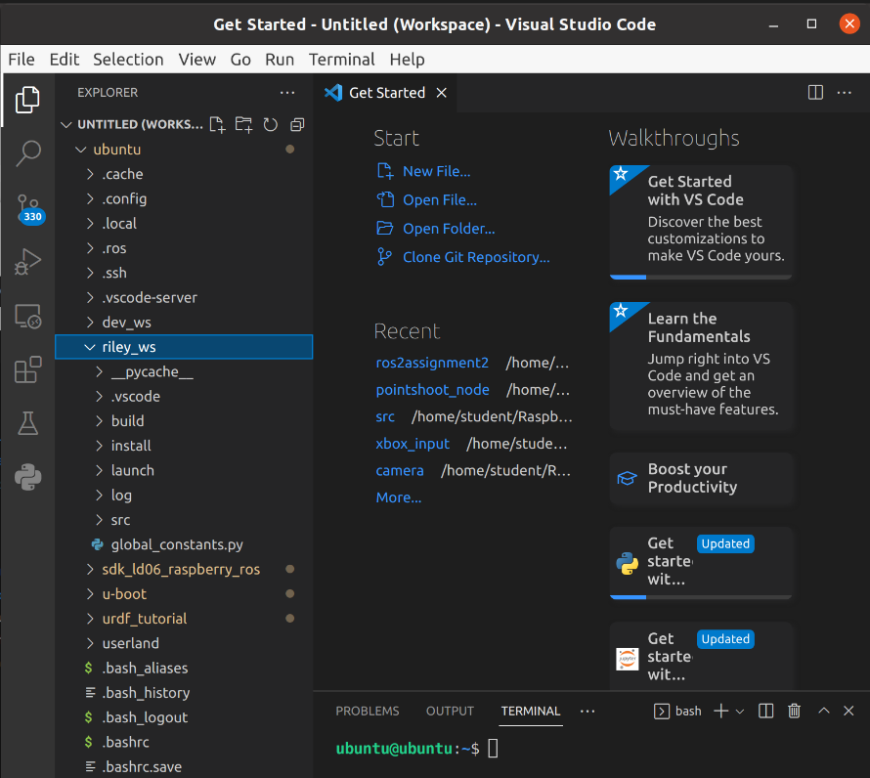 called “src” and “launch”.

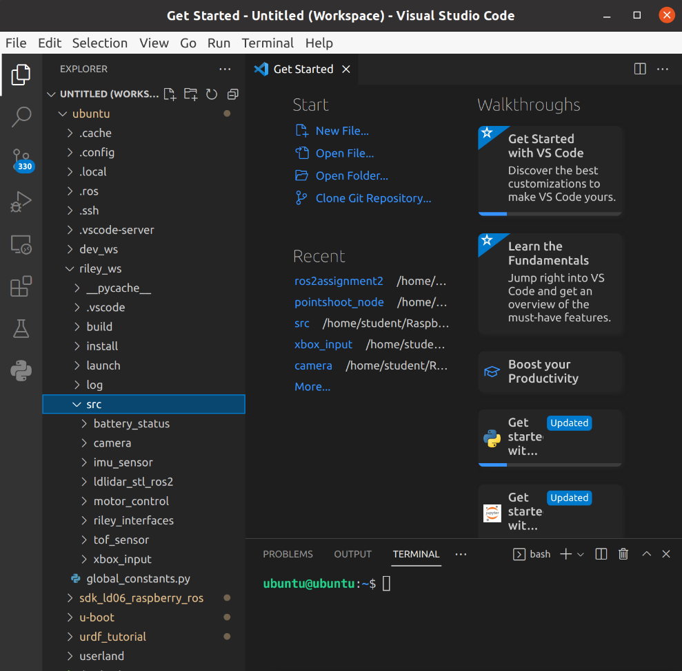

All the ROS2 packages are located in the “src” folder. All of the packages we developed for the robot contain both subscriber and publisher nodes. We make no differentiation between the server-side and RILey-side ROS2 workspaces for simplicity’s sake.

The packages are used to publish and receive information from all of the sensors on the RILey robot. In addition to that, there is a package called riley_interfaces which contains all of the custom message types used to carry the robot’s sensor data across the network.

Also, the xbox_input package is used to control the RILey using an Xbox (One) controller. This can be updated as desired to add support for more/different controllers. The controls being sent are the left joystick’s data and the Xbox burger menu button to toggle the motors on/off.

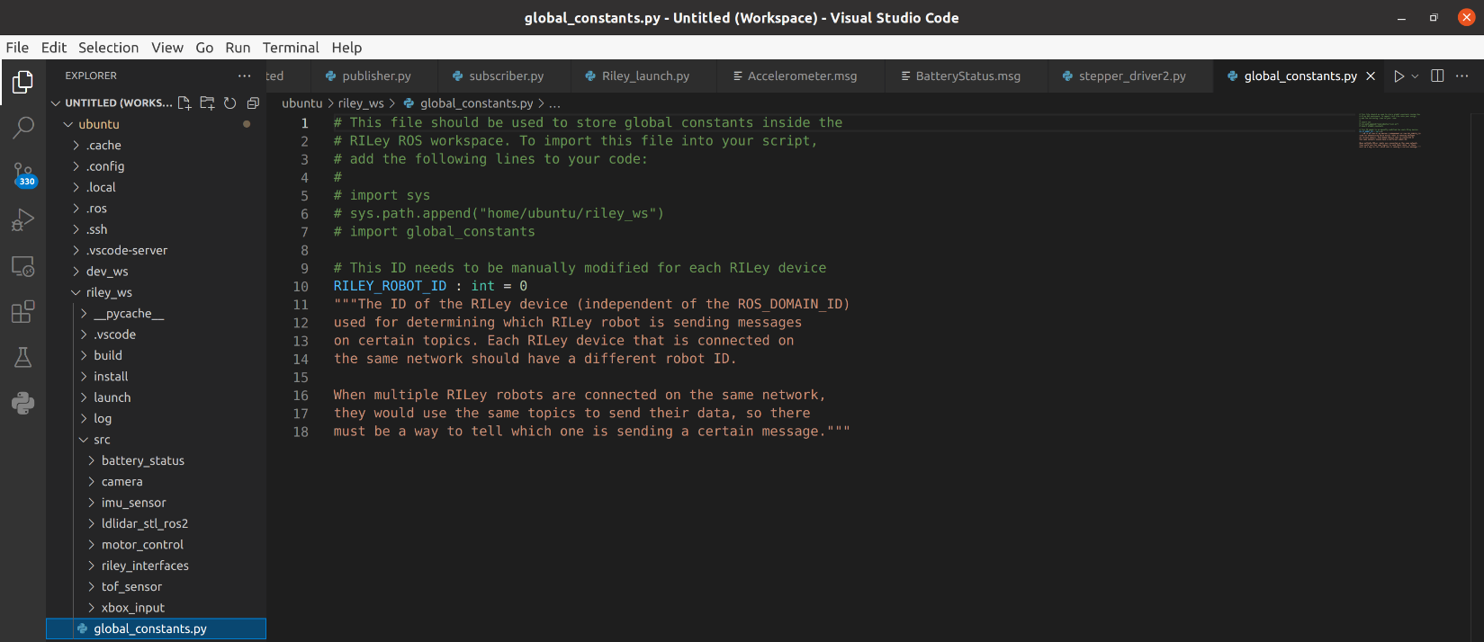as last there is also a Python script which defines a RILEY_ROBOT_ID this is unique integer for every riley robot that’s needed for communication.

In the “launch” folder there is a Python script called Riley_launch.py which will launch all the ROS2 packages that need to run on the Raspberry Pi of the riley robot.

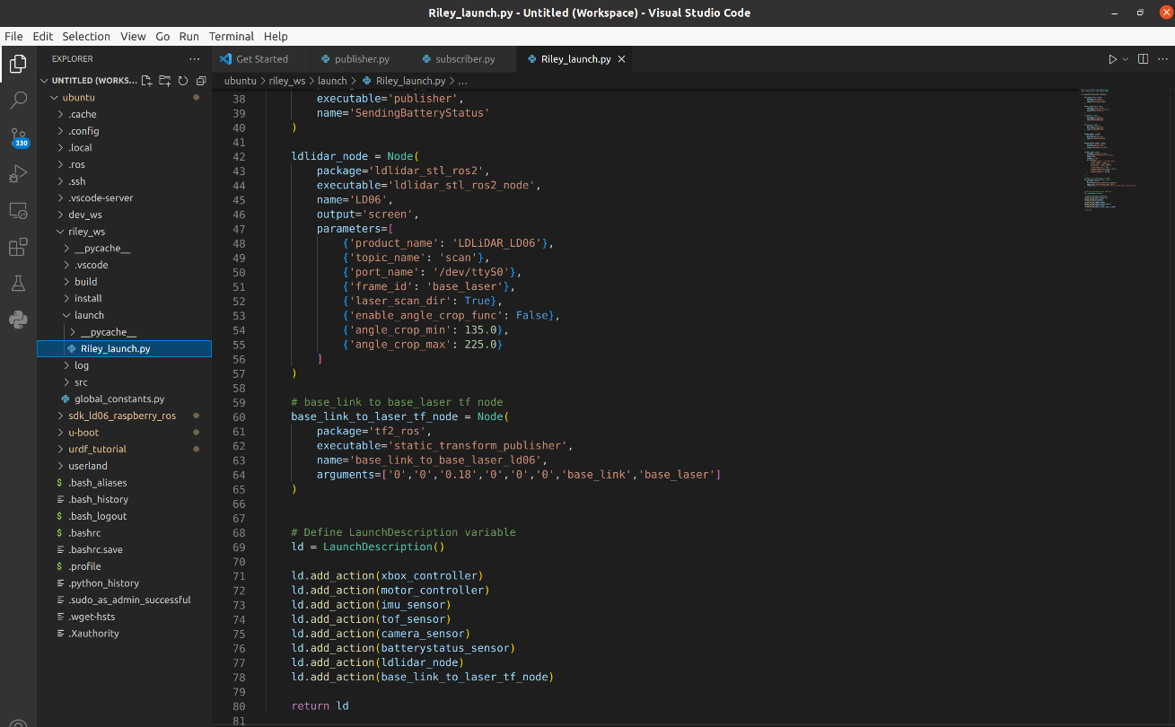

**7.1 How to run the program on the RILey Robot**

Connect to the RILey Robot and open a terminal. There you have to run a file with a few set of commands:

First go to the ROS2 workspace riley_ws

**$ cd riley_ws**

There we have to source the ROS2 packages

**$ . install/setup.bash**

After that we go to the launch directory

**$ cd launch**

Then we can run the launch file which will start up all the ROS2 nodes

**$ ros2 launch Riley_launch.py**

**7.2 How to run the program on the Server Side**

The server side should be a Linux-based OS (we worked with Ubuntu 20.04 LTS). ROS2-foxy does not support non-Linux operating systems. Before anything, you will need to install ROS on Ubuntu by following the official tutorials included in the ROS2 public documentation.

Then, retrieve the source code of the RILey ROS2 workspace by cloning the Github RILey repository from <https://github.com/fontysrobotics/Riley_ARMinor_2022>. Inside it, the ros2/riley_ws folder contains all of the ROS2 packages needed to run both the robot and server side. However, this source will need to be built before it can be used.

First go to the ROS2 workspace riley_ws and build it

**$ cd riley_ws**

**$ colcon build**

Once everything has finished building, source the ROS2 workspace

**$ . install/setup.bash**

After that go to the launch directory

**$ cd launch**

Then we can run the launch file which will start up all the ROS2 nodes on the server side, similarly to the robot side.

**$ ros2 launch Server_launch.py**

**8 Simulation**

If you want to test the riley robot or later even want to try to work with several riley robots, it will be pretty useful to have a simulation environment. But before you even make a whole simulation environment you should first make a model for the riley robot to get in the environment.

**8.1 Xacro/URDF model**

This model is called a URDF model (or Xacro model). The URDF model will describe the real riley robot. You will describe the parts in there and link them together. You first need to start with a Base_link where everything will be linked back to. The base_link in this case will be the middle part from the riley robot. Beneath here you will see a example how this is done for the base_link/middlePart.

The first example is an example is for an Xacro file, Xacro is just another way to describe a Urdf. It makes certain things easier, for instance you can generate a ”wheel” macro and instantiate that 6 times with different parameters to put 6 wheels on your robot, as opposed to copying and pasting the same code six times manually. You can launch this file in rviz and gazebo. But later on if you want to launch multiple riley robots in gazebo you will need a SDF file, because this file is intended for gazebo. To make a xacro or urdf file be able to launch in gazebo you can also use gazebo tags for that. But still if you want to launch multiple it is better to have a SDF model.

The example below this is for the Urdf. But as you can see this only describes something for the visual part. This already should be enough to launch it in rviz. But as described above for gazebo you need an SDF for that. This will be described in the next part.

For you to try an do this your self (to make a urdf/xacro model) you can try the following tutorials:

* <https://navigation.ros.org/setup_guides/index.html>
* <https://docs.ros.org/en/foxy/Tutorials/Intermediate/URDF/URDF-Main.html>

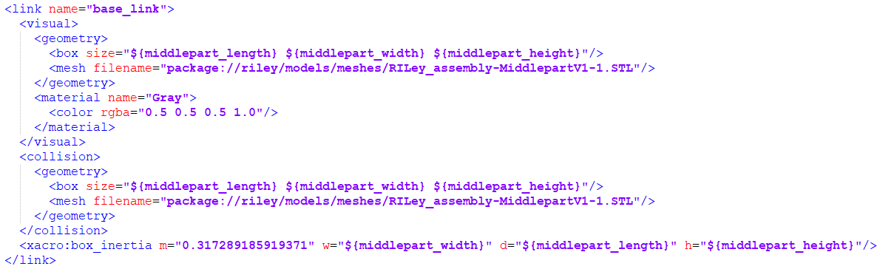

Urdf.xacro

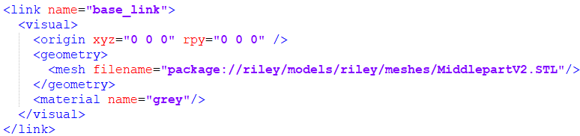

.Urdf

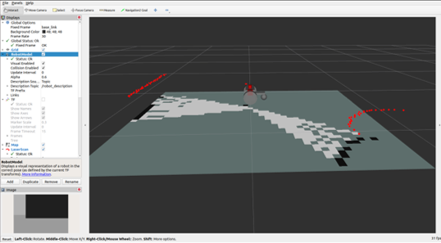

Riley model in rviz

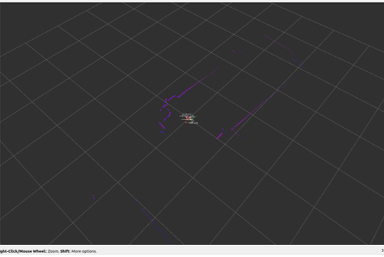 **8.2 Gazebo**

Riley model in rviz subscribed to topic /scan from laser. To get the lidar view from the real lidar.

As described earlier to properly launch your model or multiple models you need a SDF file. Beneath here you will see a example of the base_link again but then for the SDF model. Also when you want to make a world were the robot will drive in you need to make a SDF model for that.

For now a world is made for the room 1.58 were the robot can drive in. Beneath you can see an example for this.

For you to make a SDF model you can try the following tutorial: <https://classic.gazebosim.org/tutorials?tut=build_robot>

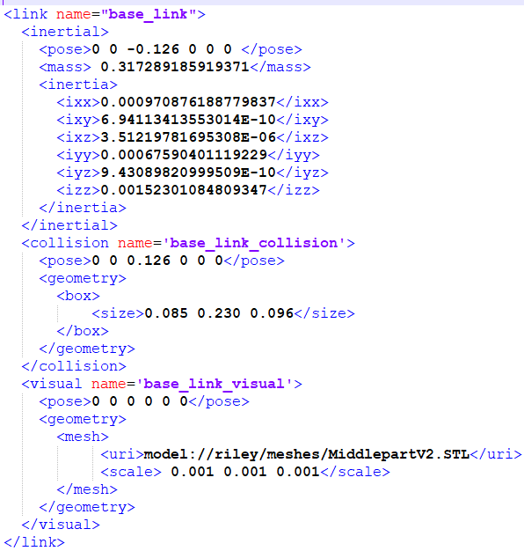

SDF

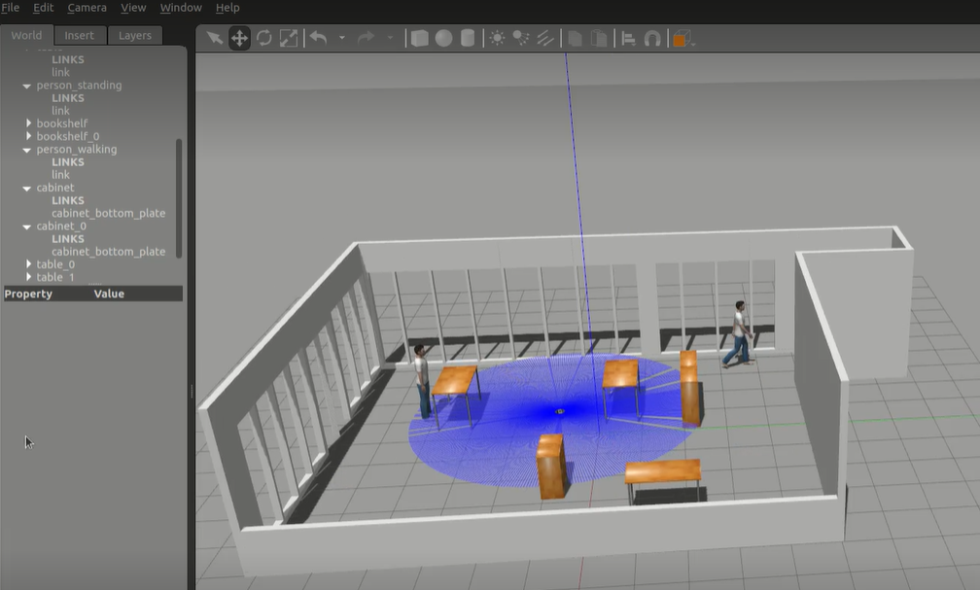

Riley model in a gazebo world (room 1.58)

**9 Object detection**

**9.1 YOLOV5**

<https://www.youtube.com/watch?v=5h5UtLau3Vc&list=PLD80i8An1OEHEpJVjtujEb0lQWc0GhX_4&ab_channel=Weights%26Biases>

<https://github.com/MiguelARD/DoorDetect-Dataset>

